
Rutgers University Treasurer’s Key
Policies and Procedures for the Student Activity Business Office

August 3, 2026
SABO-Student Activities business office
613 George St. New Brunswick, NJ 08901

August 2026
This document is the updated SABO Treasurer’s Key (policies and procedures)

TABLE OF CONTENTS
Table of Contents…………………………………………………………………………………………………………………………………………….1-3

Introduction ………………………………………………………………………………………………………………………………………………………4
SABO Mission Statement……………………………………………………………………………………………………………………………………4
What Do We Do? ……………………………………………………………………………………………………………………………………………….4

Accounts ……………………………………………………………………………………………………………………………………………………….5-14
Account Responsibilities ………………………………………………………………………………………………………………………………..5-7
Administrative Advisors and Advising Departments…………………………………………….……………………………………………………..6
Rutgers Student Organizations………………………………………………………………………………………………………………………………..6
Rutgers Recreation Services……………………………………………………………………………………….………………………..………………...6
Rutgers Residence Life……………………………………………………………………………………………………….…………………………………..6
Rutgers School of Pharmacy………………………………………………………………………………………….………………………………………..6
Rutgers School of Engineering…………………………………………………………………………………………………………………………………6
Rutgers School of Environmental and Biological Sciences (SEBS) ……………………………………………………………………………….6
Rutgers School of Business……………………………………………………………………………………….…………………………………………….6
Douglas Residential College and Undergraduate Education Accounts…………………………………………………………………………. 6
Account Treasurer, Account Users…………………………..………………………………………………………………………………………….…..7
Account Treasurer…………………………………………………………….…………………….……………………………………………………………..7
Account Users………………………………………………………………………………………………….…………………………………………………...7
What Can Be Paid With Your SABO Account? …………………………………………………………………………………………………………..7
Specific Restrictions………………………………………………………………………………………….……………………………………………………8
Non-Reimbursable Expenses…………………………………………………………………………………………………………………………………..8
Program Planning and Expenditures………………………………………………….……………………………….……………………………………8
Account Information……………………………………………………………………………..……………………….……………….………………..9
New Accounts………………………………………………………………………………………………………….……………………………………………9
Opening Accounts……………………………………………………………………………………………………………….……….……………………....9
AccountAccess…………………………………………………………………………………………………………………………………...……………..….9
SABO Online………………………………………………..…………..……………………………………………………………………………………….….9
In Person………………………………………………………………..…………………………………………………………………………………………..10
Annual Account Renewal ……………………………………………………………….………..…………………………………………………………..10
Account Suspension………………………………………………………….…………………………….……………………………………………………10
Account Codes and Transaction Codes…………………………………………………………………..……………………………………….11
Account Numbers……………………………………………………………………………….…………………………………..……………………………11
Line Codes………………………………………………………………………………………………..……………………………………….………………..11
Control Accounts………………………………………………………………………………………………..……………………………………….……….11
Transaction Codes………………………………………………………………………………………………………………………..……………………..11
Deposit and Income Transaction Codes……………………………………………………………………………………………………………….…11
Funding and Spending…………………………………………………………….…………………………………………………….…………………12
Budgets and Allocations…………………………………………………………………………………………………………………………..……….....12
Withdrawal Policy………………………………………………………………………………………………..………………………………………….……12
Spending Policies…………………………………………………………………………..…………………………………………………………………….12
Tax Exempt Status………………………………………………………………………………..……………………………………..……………………..12
Return of Unused Allocations / Takebacks……………………………………………………..……………………………………………..………..13
Reconciling Your Account…………………………………………………………………………..……………..…………………………………….13
Statements………………………………………………………………………………………………………………..………..………………………………14
Account Ledger……………………………………………………………………………………………………………………….….……………………….14
Why Does Reconciling Matter? ……………………………………………………………………………………………..……………..……………….1
Transactions…………………………………………………………………………………………………………………….………………………………15
Check Requests / Withdrawals…………………………………………………….………………………………………….……………………..15
Processing and Approval…………………………………………………………………….………………………………………………………………..16
Cash Advance………………………………………………………………………………………..……………………………………………………….16-21
Personal Expense Reimbursement Request (PERR) …………………………………………………………….…………………………..…22-27
Individual Contracts……………………………………………………………………………………………..………………………………………………28
Payments to Vendors……………………………………………………………………………………..…………………………………………………….28
Pay by Invoice…………………………………………………………………………………………………………………..…………………………………28
Vendors Requiring a Deposit or Advance Payment……………………………..……………………………………………..…………………….29
Paying Vendors by Contract…………………………………………………………………………………………………………………………………..30
Payments to Rutgers University…………………………………………………..…………………………………………………………………………30
Donation (Charitable) Advance………………………………………………………………………………………………………………………………30
Reconciling Cash Advances……………………………………………………………………………..……………………………………………….……30
Voided Checks, Stop Payments …………………………………………………………………..……………….……………………………………….30
Documentation ……………………………………………………………………..…………………………………………………………………………….32
Contracts……………………………………………………………………………………………………….……………………………………………………32
- Contracting with Individuals…………………………………………………………………………………………………………………………….….32
- Documentation for Contracts………………………………….…………………………………………………………………………………………..32
- Free Services……………………………………………………………………………………..……………………………………………………………..33
- Paying University Faculty, Staff, or Student Staff for Services…………………………….………………………………….……………….33
Receipts …………………………………………………………………………………………………..…………………..…………………………………...33
- Original Receipts……………………………………………………………………………………………………………………….……………………….33
- Itemized Receipts………………………………………………………………………………………………………………………………………………33
- Personal Items on Submitted Receipts……………………………………………………………………….………………………………………..33
- One Receipt, One Reimbursement……………………………………………………………………………………………………………………….33
Invoices…………………………………………………………………………………………..………..……………………………………………………….33
Documentation for Online Purchases ……………………………………………………………….……………………………………………………33
Additional Documentation for Specific Spending Policies……………………………………………….…………………………………………33
Transfers……………………………………………………………………………………………….…………………….……………………………………34
Online Transfers Between SABO Accounts ……………………………………………………………………………………………………………..34
Co-Sponsoring Events………………………………………….……………………………………….………………………………………………….…..34
Online Transfers Between Line Codes.…..……………………….…………………..…………………………………………………………….…..35
Deposits…………………………………………………………………………………..……………………………………………………………………….35
Deposit Slip…………………………………………………………………..…………………….………………………………………………………………35
Depositing Checks and Money Orders…………………………………………………………….………………………………..…….……..………36
Depositing Coins and Currency……………………………………………………………………………….………………….……….………………..36
Generated Revenue…………………………………………………………………………………………………………….…………….…………………36
Deposits from Events at Student Centers ………………………………………………………………………………..…………………………….36
Funding from Other Rutgers University Sources…………………………………………………………..……………..…………………………..36
Donations Received From Outside Sources…………………………………………………………..………………….………….………………...37
Restrictions on Deposit Transactions……………………………………………………………..……………………….……………………………..37
Wire Transfers…………………………………………………………………………….…….……………………………………….…………………….…37
Electronic Funds Transfer…………………………………………………………..……….……………………………………….…………………….…34

Specific Spending Policies…………………………………………………..………………………………………………………………………….38
Food ………………………………………………………………….……………………………………………………………………………………..….…38
Travel …………………………………………………………………….………………………………………………………………………………….......38
Travel Suggestions……………………………………………………………..……………………………………………………………………….….…..38
Travel Finances………………………………………………………………………..………………………….……………………………….……………..39
University Representatives………………………………………………………………..………………………………………….……………………...39
Reimbursing Travel…………………………………………………………………………………….……………………….……………………………….39
Airbnb/VRBO/Home-Sharing…………………………………………………………………………………………………………………………………
Traveling with a Cash Advance……………………………………………………………………………………….…….………..…………………….40
Travel Outside of the US………………………………………………………………………………………………………………………………………41

Printing, Publications, and Advertisements ………………………………..………………………………………………………………….41
Trademark Licensing Program for Imprinted Supplies …………………..……………………….…………………………………….41
Giveaways ……………………………………………………………………………………………..…………………………………………………………41
Scholarships …………………………………………………………………………………………………………………………………………………….41
Charitable Donations …………………………………………………………………………………….…………………………………..……………41
Prizes, Awards, and Gifts ……………………………………………………………………………………………………………………….…….…42
Required Documentation for Prizes, Awards, and Gifts…………………………………………………………………………………………….42
Compensating University Employees ………………………………………………………………….…………………………………….……43

Appendices……………………………………………….…………………………………………….………………………………………………………..43
Glossary of Terms ………………………………………………………………………………………………………………………….………………..43
Links…………………………………………………………………..………………………………………………………………………………..…………..44
Contacts………………………………………………………………….…………………….…………………………………………………………….……44
Sample Forms…………………………………………………………..………………………………………………………………………………….44-52

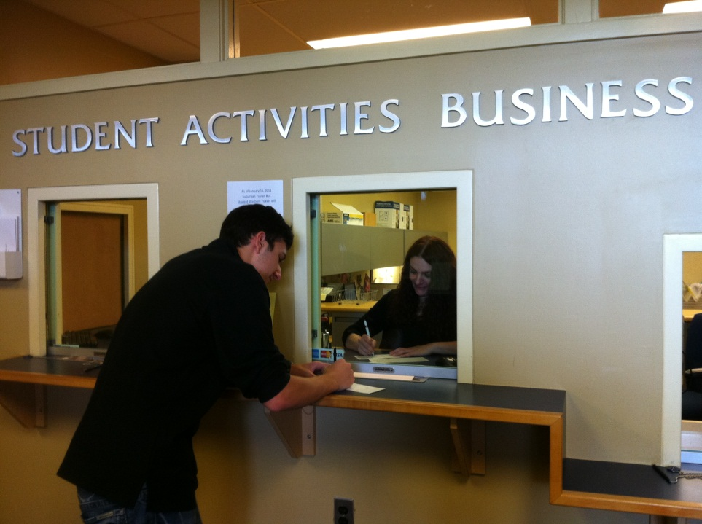

“THE TREASURER’S KEY – YOUR GUIDE TO SABO SUCCESS”

Introduction – The Rutgers University Student Activities Business Office, Student Activities Center, 613 George Street, College Avenue Campus, Hours: Monday – Friday, 9:00 AM to 4:30 PM, Phone: 848-932-6981
Email: sabo@echo.rutgers.edu, Website: https://sabo.rutgers.edu

SABO Mission Statement: The Student Activities Business Office (SABO) administers and manages the financial resources of the undergraduate and graduate student governments, student organizations and other similar student-focused, student-driven organizations of Rutgers University and limited departments of Rutgers University. The SABO manages the Rutgers University Student Fund, which is comprised of student fees, generated revenue, dues, and allocated funds from within Rutgers University. The SABO provides the management and administrative infrastructure necessary to facilitate the unique needs of its Account Holders and the Schools and University departments responsible for student organizations and their programs. SABO is structured to offer sound fiscal management within a student development context, providing valuable learning experiences for Account Holders. The Student Activities Business Office is dedicated to supporting their Account Holders’ diverse needs by developing policies, procedures, systems, and internal controls to ensure compliance with all University policies while providing quality customer service.

  - What do we do? – The SABO provides efficient and timely accounting and financial services to Account Holders, and provides information and assistance in opening, closing, general use, and maintenance of accounts.

In addition, we:
      - Ensure compliance with all University policies and procedures in relation to the use of student and University funds.
      - Aim to ensure our Account Holder’s compliance with the policies and procedures of their funding sources and Administrative Advising departments.
      - Educate Account Holders on fiscal management responsibilities and concepts and provide tools to assist them in managing their accounts.
      - Protect the University against risk associated with the use of allocated or generated funds.

It is against Rutgers University policy for recognized student organizations to establish or maintain accounts at banks, credit unions, or any type of financial institution. Rutgers University requires that all registered Account Holders receive more than fifty percent of their funding from Rutgers and maintain all their funds (including dues, donations, student fee allocations, and other generated income) with the SABO.

Currently we service many areas of student organizations within Rutgers University.
This list includes Rutgers University registered undergraduate and graduate student organizations, Rutgers University Program Association (RUPA), Class Treasuries, Rutgers University Recreational Sports Clubs, Rutgers University Residence Hall Associations, Rutgers University Off-Campus Student Association, School of Business, School of Engineering, School of Environmental and Biological Sciences (SEBS), School of Pharmacy, Mason Gross, Honors College and DRC.
Accounts

  - Account Responsibilities

Administrative Advisors and Advising Departments - Each account held at the Student Activities Business Office has an Administrative Advising department and governing area. The Administrative Advising department authorizes the opening and the ongoing existence of the account, provides advice to the Account Holders, and may also fund the account. The Administrative Advising department is responsible for the oversight of the account and the Account Holders.

The Administrative Advisor’s role is to assist organizations and associations in program planning, logistical arrangements, and to interpret School, University, departmental or SABO policies, procedures, and guidelines that apply to them.

      - For Rutgers Student Organization Accounts Registered with the Student Activities Involvement Office - In addition to consulting with their Advisor, registered Rutgers student organizations should refer to the Rutgers “Student Organization & Advisor Handbook” for the current year for funding, allocations, fundraising, & spending policies.

      - For Rutgers Recreation Services Accounts – In addition to consulting with their Advisor, registered Rutgers Recreation Services and club sports accounts should refer to the “Sport Club Handbook” for the current year concerning funding, allocations, fundraising, and spending policies. Club Sports | Recreation - Division of Student Affairs | Rutgers University-New Brunswick

      - For Rutgers Residence Life Accounts – Rutgers Residence Life Account Holders should clarify all expectations with their Administrative Advisor before program planning begins. For additional questions or clarification, Residence Life Account Holders should consult a current copy of the “Rutgers Residence Life & Student Activities Business Office Budget Handbook.” Home | Residence Life - Division of Student Affairs | Rutgers University-New Brunswick

      - For Rutgers University School of Pharmacy Accounts – In addition to consulting with their Advisor, registered Rutgers School of Pharmacy organizations should refer to the Pharmacy Governing Council’s policies for the current year concerning allocations, fundraising, and spending policies: https://sites.rutgers.edu/pgc/

      - For Rutgers University School of Engineering Accounts – In addition to consulting with their Advisor, registered Rutgers School of Engineering accounts should refer to the Engineering Governing Council’s policies for the current year concerning allocations, fundraising, and spending policies: Rutgers Engineering Governing Council – Rutgers Engineering Governing Council

      - For Rutgers University SEBS Accounts – In addition to consulting with their Advisor, registered SEBS accounts should refer to the SEBS Governing Council’s policies for the current year concerning allocations, fundraising, and spending policies: Welcome to SGC!

      - For Rutgers School of Business Accounts – In addition to consulting with their Advisor, registered School of Business accounts should refer to the Rutgers Business Governing Association’s policies for the current year concerning allocations, fundraising, and spending policies: Rutgers Business School | Rutgers Business School

      - For Douglas Residential College Accounts and Undergraduate Education please consult with the professional staff and/or business staff before using the on-line system. Homepage | Douglass Residential College

      - For Graduate Student Organization Accounts – In addition to consulting with the GSA Business Manager, registered GSO accounts should refer to the GSA Governing Council’s policies for the current year concerning allocations, fundraising, and spending policies: https://gsa.rutgers.edu

Account Treasurer and Account Users

      - Account Treasurer - Each account or organization must elect or appoint a person to serve as Account Treasurer for the account. This person is chosen according to the rules and regulations established by that account’s Administrative Advising department. The Account Treasurer is personally and solely responsible for all transactions associated with the account he or she represents. Failure to follow all rules and regulations may result in a hold on the Account Treasurer’s personal University transcripts and personal University account, as well as other University disciplinary measures. Only one person will be recognized as the Account Treasurer and have online access for their account. The Account Treasurer is responsible for maintaining his or her own Account Ledger and for reconciling the Ledger with Account Statements generated through the SABO Online system. The Treasurer has full transaction access in SABO Online. The President has read-only access. This will give them the ability to review transactions entered by the Treasurer.

The Account Treasurer must ensure that the account does not go into a deficit balance and that all expenditures are within budgeted amounts. The Account Treasurer must also ensure that all expenditures follow all applicable University, School, Allocations Boards and SABO guidelines. It is the Account Treasurer’s responsibility to know what restrictions, if any, apply to funds from each individual source (i.e.: student fee allocations, donations, generated revenue, etc.). The Account Treasurer is responsible for ensuring that all expenditures are properly documented and approved by the Administrative Advisor or other organization or association officers.

The Account Treasurer is responsible for all information in this guide and for sharing it with any other officers or members. The Account Treasurer must ensure that no commitments (contracts, promises to make purchases, etc.) are made, either by the Account Treasurer or any other members, until all appropriate approvals have been received and all program planning procedures have been followed. The Account Treasurer should advise members not to make “out of pocket” expenditures on behalf of the account unless previously authorized.

While the Account Treasurer maintains responsibilities distinct from other people with access to the account, for the purpose of access to the SABO Online system and ability to conduct account business, the Treasurer is an Account Holder.

      - All Account Users - requesting reimbursement or cash advance requests must follow all specific rules, guidelines, policies and procedures of the University and the Advising office. Failure to adhere to the information set forth in the Treasurer’s Key, or direction from SABO staff, may result in account suspension and the denial of reimbursement or cash advance request.

What Can Be Paid with Your SABO Account? - The policies governing expenditures of student fees, student organization Generated Revenue, Residence Life, Recreational Sport Clubs, and all other funds held by the Student Activities Business Office (SABO) are provided by the University, individual departments, Administrative Advising departments, and the SABO. The policies and procedures listed in this guide apply to all SABO accounts and are a summary of University and SABO policies and procedures.

These policies and procedures have been developed to minimize risk to the University and to student organization members, officers, and advisors, and to provide adequate audit trails, reporting procedures, etc.

Additional policies and procedures exist for each of the University and professional schools and are provided by the Administrative Advising departments, Student Life offices, etc. The SABO makes every effort to provide information regarding these policies and to enforce University and School based policies. For specific details on the additional policies which govern your organization, consult with your Administrative Advising department.

      - Specific Restrictions

- Payments or wages to individuals (other than reimbursements) who are employed by the University cannot be paid through SABO. These employees must be paid through University Payroll Services.
- Check Requests may not be initiated and will not be processed by the SABO for alcoholic beverages, controlled substances, bail, parking tickets or moving violations of any kind, legal fees, lobbying, wages (not including payments to individual contractors), or personal loans. All Withdrawals require an approved Check Request submitted to SABO.
- The SABO cannot process foreign payments and does not have the ability to wire transfer.
- Check Requests by any Account Holder over $3,500 who has access to the University Purchasing System (RU Marketplace). Some exceptions may apply.
NON-REIMBURSABLE EXPENSES
Although not a complete list, this list offers examples of expenses that will not be reimbursed by Rutgers University – Student Activities Business Office (SABO)
- Fees incurred for changing reservations e.g., late check out fee, room upgrade, etc. (unless there is a business justification)
- Expenses and/or fees associated with social or non-mandatory activities at conferences such as tours, sports activities, golf outings, fun runs, movies, theater tickets, in-room movies, in-flight movies etc.
- Unreasonably expensive meals and lodging. Gratuity for sit-down meals is limited to no more than 20% of meal total.
- When ordering from a delivery service like Door Dash, Grub Hub or Instacart, the service charge, delivery fee, tip/gratuity in total cannot be more than 20% of the cost of item(s) purchased.
- Paying for an expense using VENMO (or any other non-cash app like Zelle/CashApp) to a person/entity(unless there is a business justification)
- Any goods or services for student organizations purchased OUTSIDE of the United States
- Expenses that are not Rutgers student organization/club related
- Meals included in the cost of conference/meeting fees/meets.
- All expenses related to the personal negligence of the traveler (parking tickets and fines, towing, traffic violations, damage to personal vehicles, clothing, or other items)
- Laundry or valet service
- Purchases made using a gift card, account credits or using personal airline miles are not reimbursable.
- Lost/stolen cash or personal property, including luggage and/or backpacks.
- Personal items and services (e.g., shoeshines, haircuts, manicures, saunas, massages, pet care costs, souvenirs or personal gifts, and personal reading materials).
- Late payment penalties and interest on personal credit cards
- Alcoholic beverages
- Frequent flyer or club membership (air, lodging, or rail), preferred seating, “cancel any time” fees.
- The purchase of travel, accident, or life insurance for a student organization-related trip
- SWAG purchases not through Consolidus. All swag purchased by a SABO accountholder must be made through Consolidus.
- Personal donations
- If any personal items are bought on the same receipt as SABO items, the whole receipt will not be reimbursed(make sure you separate your items)
- Wire transfers
  - Please note The SABO account is restricted meaning only US payments can be made:
    - No outgoing wires
    - No incoming wires
    - No ACH/EFT
    - No international payments
    - Program Planning and Expenditures - The Account Treasurer should ensure that all events are carefully planned and executed, following approved Program Planning procedures through your Administrative Advising department. These procedures must address risk management issues, security needs, proper execution of contracts, technical requirements, financial planning, etc.

In addition to proper event planning, the SABO and each Administrative Advising department maintain rules and guidelines governing appropriate expenditures. Before spending personal funds or committing allocated funds or generated revenue to anything, it is always advised that the Account Treasurer consults the appropriate usage or spending policy.

  - Account Information

For RUSA, SEBS, RBGA only
To register a new student organization at Rutgers, please visit the Suitable website: [UPDATE WITH LINK TO WEBSITE]

Opening Accounts* All new groups must be registered under a student government association. The SABO does not permit independent group account holders. If a group is unsure of their eligibility to open a SABO account, please contact the Registration Office at: Student Organization Registration | Student Centers and Activities - Division of Student Affairs | Rutgers University-New Brunswick
*Please contact your Advising Department regarding opening of new accounts.

  - Account Access

      - SABO Online - Access to the SABO Online system is maintained through the SABO staff. All online users must have a valid Rutgers NetID. The Treasurer has full transaction access in SABO Online. The President has read-only access.

        - Signing In to SABO Online – Open an internet browser and go to http://sabo.rutgers.edu. From the SABO homepage, click on the SABO Online link. The SABO Online Log In screen should appear as below:

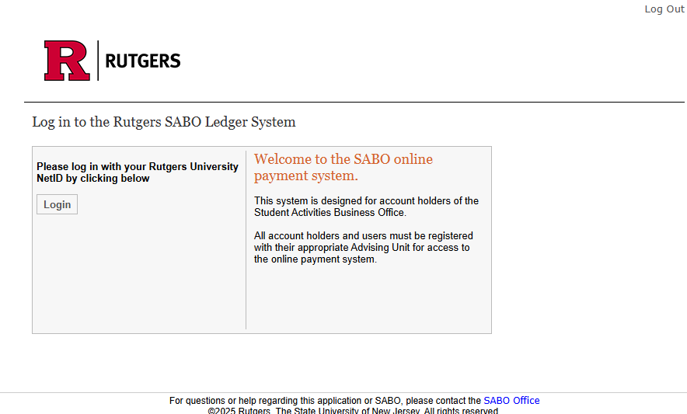
After clicking Login, enter your Rutgers NetID and Password in the fields provided.

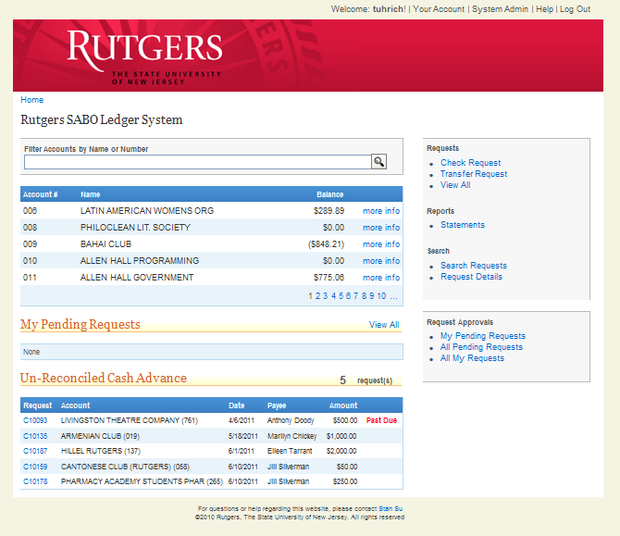
Welcome to the SABO Online Dashboard! From here, you can see all accounts you have access to, submit Requests, and access your statements.
Links in this box will help you initiate Requests, see Statements, and search the SABO Online system.
All accounts that you have access to will appear here.
Note the navigation tools on your Dashboard. You can click on links like “more info” for detailed account and line info, or “View All” either in the upper right box or in the My Pending Requests box to see Requests you already submitted.

    - In Person – Normally, Account Holders must come to the SABO window in person to deposit Generated Revenue and to submit documentation. In some circumstances, arrangements can be made with your Administrative Advising department to have your documentation forwarded to the SABO directly.

    - Annual Account Renewal - Annual Renewal of accounts takes place via the submission of the governing council roster.

    - Account Suspension -
      - Funds withdrawn from the SABO through a Cash Advance must be reconciled within 30 days from when the check was issued (check date), not when check was picked up. Accounts with delinquent Cash Advances over 60 days are subject to suspension at the discretion of SABO staff.
      - Misuse of funds, including Generated Revenue, is also grounds for suspension of SABO accounts. Funds held by the SABO may not be used for alcoholic beverages, controlled substances, bail, parking tickets or moving violations of any kind, legal fees, lobbying, wages (not including payments to individual contractors), or personal loans. Most funding and allocations also come with spending restrictions – failure to adhere to the spending policies of funding sources and Administrative Advising departments is the responsibility of the Account Holders, not the SABO.

  - Account Codes and Transaction Codes - Filling out SABO forms and requests requires an understanding of the SABO identifiers used for accounts, for coding transactions, and for identifying the source or types of funds being accessed.

    - Account Numbers - The most basic code needed is an Account Number. Like a personal checking account number, it is a three- or four-digit code uniquely assigned to each account. In the SABO Online system, the Account Number will often be visible and will be added to forms and requests automatically. If Account Holders complete the forms by hand, most often a Deposit Slip, the Account Number must be included. SABO staff will also ask for the Account Number when a check is being picked up.

    - Line Codes - A Line Code is like an Account Number. A “Line” or “Line Code” acts as a sub-account, or an account within the account. Line Codes are used to identify either the source of funds, the intended use of funds, or to isolate the accounting for annual events or projects. When funds are allocated to an account, they are allocated by Line Code and often cannot be transferred between Lines. A common Line in a SABO account is Line 137 for Generated Revenue. Other Line Codes are assigned by Administrative Advising departments and each of these Lines denotes how or why funds may be spent. This helps funding sources to ensure that SABO Account Holders adhere to their submitted budgets. Please consult with your Administrative Advising department for additional Line Code information.

    - Control Accounts - Each account is also assigned a Control Account. A Control Account code indicates which Administrative Advising department is responsible for the account. The Control Account code, which can be seen on SABO forms and statements ahead of the Account Number, is a three-digit number beginning with a “9”.

    - Transaction Codes - Each Transaction process must be assigned a valid Transaction Code in the SABO online system, and at the window at the SABO office, when making a deposit. A Transaction Code is a very brief description of the origin of your expense or deposit, for instance, how Generated Revenue for deposit was raised or collected.

DEPOSIT AND INCOME TRANSACTION CODES

Beginning Balance | 001
Donation Income | 062
Dues Income | 060
Fundraising Income | 021
Income Allocation | 004
Interest Income | 056
Investment Income | 057
Other Income | 017
Sales Income | 070
Student Fees Received | 003
Ticket Sale Income | 035
Travel Income | 037
  - Funding and Spending - Rules and policies concerning funding from university sources and how those funds can be spent are often not determined by the SABO. Many of the SABO usage policies are provided by university units and departments including the Division of Student Affairs, Rutgers University Student Assembly, School of Pharmacy, School of Engineering, Rutgers Residence Life, and Rutgers Recreation Services, as well as several others. Because of our diverse group of users, policies set forth in this guide provide a baseline to our users and departments but cannot specify all additional rules and policies of individual departments. Your unit, department, or School may have more restrictive or more specific steps they wish you to take regarding certain types of purchases. If you have specific questions about obtaining funding or policies about spending, please consult with your Administrative Advisor.

  - Budgets and Allocations - The SABO is not involved in the budgeting request process or allocation of money to accounts. SABO receives allocations on behalf of Account Holders from various funding organizations, governing councils, and sometimes departments and then assists Account Holders in accessing their funds safely to facilitate their goals and outcomes. Questions about funding, budgets, or allocations should be directed to your Administrative Advising department.

  - Withdrawal Policy - The policies governing expenditures of student fees, student organization Generated Revenue, Residence Life, Recreational Sport Clubs, and all other funds held by the Student Activities Business Office (SABO) are provided by the University, individual departments, Administrative Advising departments, and the SABO. The policies and procedures listed in this guide apply to all SABO accounts and are a summary of University and SABO policies and procedures.

These policies and procedures have been developed to minimize risk to the University and to student organization members, officers, and advisors, and to provide adequate audit trails, reporting procedures, etc.

All Account Users requesting reimbursement or cash advance requests must follow all specific rules, guidelines, policies and procedures of the University and SABO office. Failure to adhere to the information set forth in the Treasurer’s Key, or direction from SABO staff, may result in account suspension and the denial of reimbursement or cash advance request.

Additional policies and procedures exist for each of the University and professional schools and are provided by Administrative Advising departments, Student Life offices, etc. The SABO makes every effort to provide information regarding these policies and to enforce University and School based policies. For specific details on the additional policies which govern your organization, consult with your Administrative Advising department. (See Specific Restrictions, pg. 7)

- Spending Policies - Policies on spending may vary widely by your Administrative Advising unit or department. It is the responsibility of Account Holders, not SABO, to abide by the spending policies and practices of your funding source and your Administrative Advising department. If you plan to use University funds or Generated Revenue for any of the following items or activities, it is required that approval from your Administrative Advisor be received before any advertising begins, before personal monies are spent, and before commitments are made: food, travel or travel related expenses, advertising publications or copying, production of imprinted items (t-shirts, buttons, etc.), giveaways, scholarships, donations, prizes awards or gifts, or compensation for University faculty or staff (See Specific Spending Policies, pg. 37).

Approval is required because some University policies apply to all groups regardless of the source of funding, some restrict only the spending of university funds, and ALL require some form of additional documentation or authorization to be submitted to the SABO. Even if no funds are being spent (for example, a musician performing for free) consult with your Administrative Advisor to determine if a contract may be necessary to protect the interests of your organization or association, your members, and any potential guests (See Contracts, pg. 29). A contract is required for performers, artists, musicians and DJs, non-University caterers, equipment rentals, referees, and, more generally, anyone providing a service to your group or association.

- Tax Exempt Status - SABO accounts benefit from Rutgers University’s Tax-Exempt Status ONLY when funds are dispersed by a SABO-issued University check. If a vendor requires a letter accompanying the check to verify Rutgers’ tax-exempt status, please request one from the SABO in advance of picking up a check. Tax Exempt Status is not extended to reimbursements or any transaction paid for by cash or credit card. This status also does not extend to fraternities and sororities.

  - Return of Unused Allocations / Takebacks – Most funding sources and Administrative Advising departments have an articulated Takeback policy. At the conclusion of each semester or academic year, it is not uncommon for funding sources to require the return of any unused allocated or budgeted funds. In most cases, SABO does this for Account Holders automatically. Account Holders should consult with their Administrative Advising department about Takeback and allocation return policies. Unlike allocated funds or budgeted funds, revenue generated by most Account Holders is permitted to carry over from year-to-year unless restricted by the Administrative Advising department.

  - Reconciling The Account - SABO recommends that at least once a month and at the end of each semester, Account Treasurers reconcile their account. The account is reconciled by comparing the Ledger the Treasurer maintains against the generated Account Statements to verify that they agree. Any discrepancies should be presented to your Administrative Advisor or SABO representative promptly.

    - Statements – There are two types of statements – Account Statements and Request Details. Account Statements are a more general overview of the account activity, where the Request Detail provides additional information on PERR and Cash Advance transactions. Statements of the current academic year are available on demand using the SABO Online system. Account Holders may access the SABO Online system to view, print, or download statements as .pdf files for any activity from academic year 2011-2012 forward. Statements will reflect approved transactions, not necessarily Check Requests waiting to be approved.

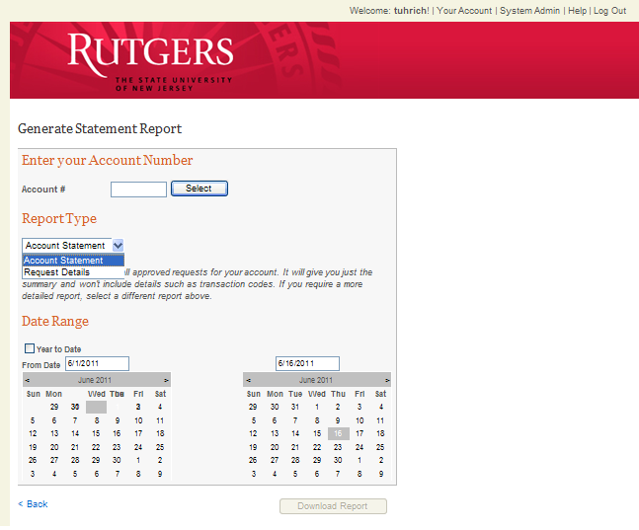
4. Download statement as .pdf.
3. Choose a date range for the statement or click “Year to Date”.
2. Select “Account Statement” or “Request Details”.
1. Enter the Account Number.
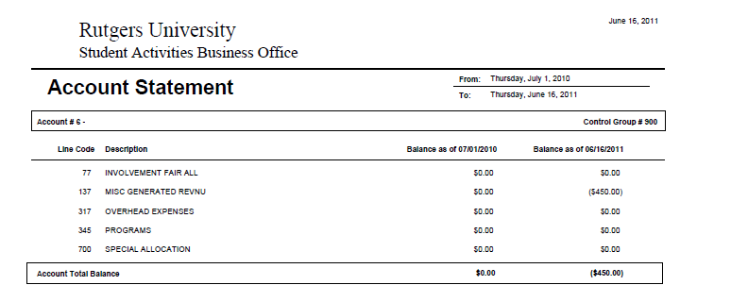
Your Line Codes
Beginning and ending balances
Your Specified Date Range

A typical example of page 1 of an Account Statement is above. The Statement will display the balances of all Line Codes associated with your account at the beginning and end of your specified date range.

Page 2 of an Account Statement will more closely resemble the graphic below. Note how the transactions are broken out by line, specified by “Type”, and associated with both a date and a Check Request Number. Page 2 of the Account Statement is more detailed than page 1, but less detailed than generating a separate Request Details report.

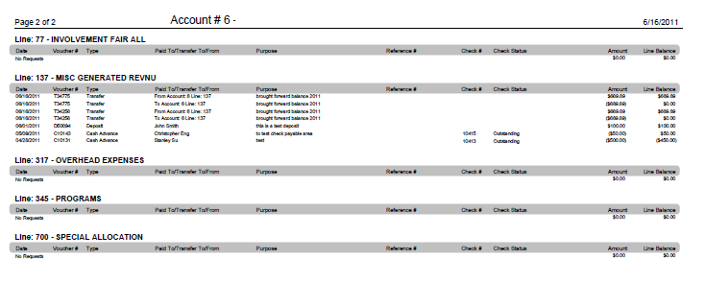
Each Transaction from Line 137 over the specified dates is listed here.
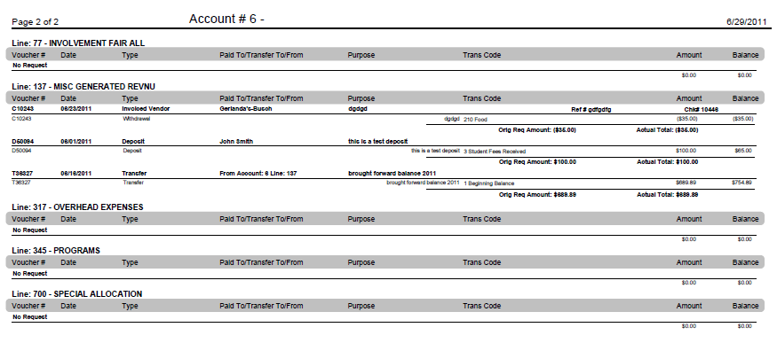
This is page 2 of a Request Details statement (page 1 of both statements looks the same). Note that the account is broken out into lines, just as on page 2 of the Account Statement. The Request Detail, however, also breaks out each transaction. On this page, Line 137 has 3 transactions listed, each with details below the transaction. If a PERR or Cash Advance has multiple Transaction Codes, all information associated with the Check Request Number will be shown.

    - Account Ledger - The Account Ledger is the Treasurer’s record of all account activity including deposits, check withdrawals, and transfers. It is important to maintain an Account Ledger so that records maintained by the Treasurer can be compared with those maintained by the SABO. Sample Ledgers are available on the SABO website (http://sabo.rutgers.edu) or in the back of this guide.

    - Why Does Reconciling Matter? - Reconciling the account helps to ensure that all Cash Advances have been cleared, that all Check Requests have been completed and approved (if they were pending due to needed documentation), and that all activity on the account has been correctly processed. For accounts that request many checks or Cash Advances, or accounts with multiple Account Holders processing transactions, reconciling monthly ensures that balances are correct and that funds are available for future expenses.

Transactions - With the launch of the new SABO Online system, most transactions will have an online component prior to coming to the SABO window. Please become familiar with the new procedures and be prompt in your submission of documentation to support Check Requests and in reconciling Cash Advances.

  - Check Requests / Withdrawals – Withdrawals from the SABO will occur in the form of a check and can be issued either after an expenditure is made (PERR, Pay by Invoice) or before an expenditure is made (Cash Advance, Pay by Contract). Checks are produced by the SABO in response to Check Requests submitted via the SABO Online system. All checks produced by the SABO require the approval of your Administrative Advisor and supporting documentation (receipts, contracts, itineraries, etc.).

To initiate a Check Request, click on the “Check Request” link on the right side of the SABO Online Dashboard. You will first be asked to enter your Account Number:

Next, “Select” the Line Code from which you plan to Withdrawal the funds. This will bring you to the “Who Are You Paying?” screen.

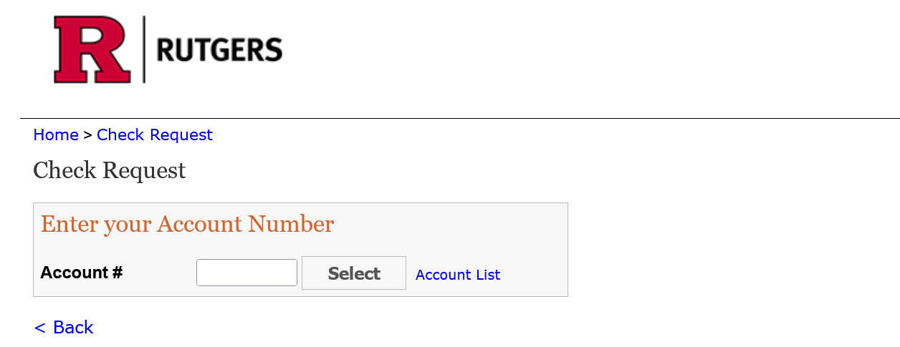
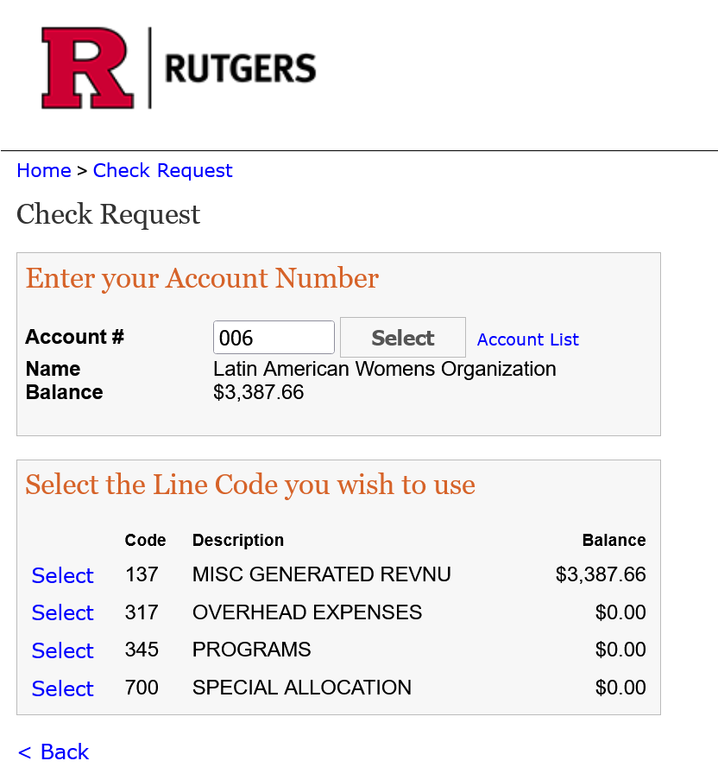
Enter your Account Number in the box provided and click “Select”. This will bring up the Line Codes associated with your account.
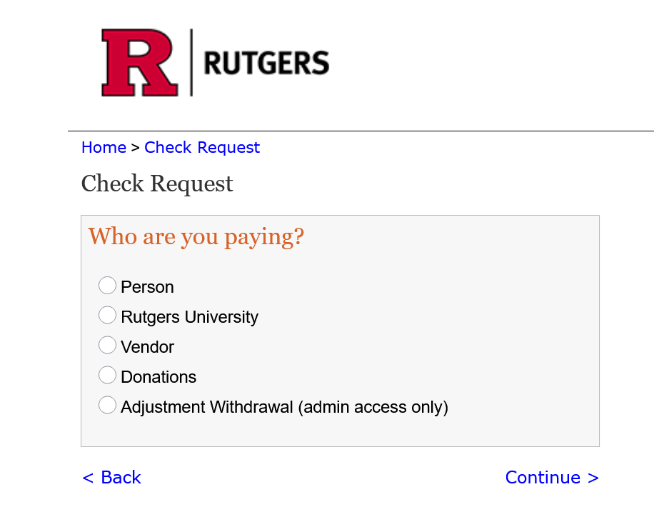
Now, select the entity you will be paying with this Check Request.

Also note the “continue” and “back” buttons. Use these instead of browser buttons. Using the browser “back” button will interfere with the entry of your information.

Selecting who you are paying will determine the type of transaction that will be processed. Please see the appropriate section under this heading: For Persons, Payments to Vendors, Payments to Rutgers University, Donation (Charitable) Advance. (Only SABO staff have access to the Adjustment Withdrawal option).

After the initial step of identifying who is being paid and how much of the information being entered into the SABO Online system will be the same. In most cases, to generate a Check Request you will need:

- The legal name of the person or business being paid (and NetID if affiliated with Rutgers)
- The mailing or home address of the payee
- A W-9 form with the addresses matching the contract address.
  - Must enter home address even if Check Delivery is marked as “Pick-up.”
- The invoice, contract, or reference number (if applicable)
- The amount to be advanced, reimbursed, or paid.
- Both short and long description of the use of funds
  - A Purpose of expense may be “Travel to Camden” or “Club Sport Tournament Fee 9/16-9/17.”
  - A Description of the expense should then include mileage, means of travel, and specifics.
- The Transaction Code of the expense (if applicable)
- Whether the check will be picked up or mailed
- Who the Approvers will be, the treasurer and your Advisor.
  - Treasurer will populate under Approver Information “1.”
  - Treasurer must select Administrative Advisor “2.”

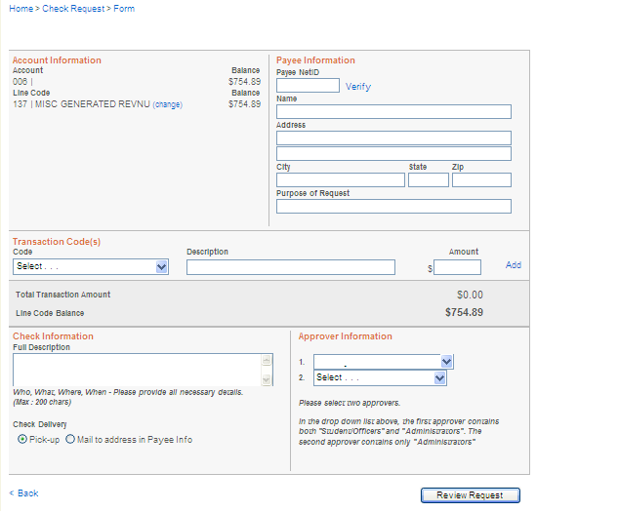
Note the circled links on this page. The tree at the top shows you how you got here. The link allows you to change the Line Code being accessed. The “Add” link allows for more items to be added as expenses for most transactions, and the “< Back" link at the bottom is for navigation purposes. Navigation in the system should be done with this “< Back” link, not with your browser’s back button.
This is a generic version of the Check Request form screen. Here you will enter the name and address of the individual or business being paid, amounts, details, and approvers. During all Check Requests, you will end up on a screen much like this one.
In some form screens, more information will be pre-filled. Defaults may include Transaction Codes (Cash Advance), address information, and the first approver already being selected. This information is generated by answering the questions and prompts in the SABO system.

    - Processing and Approval – All Check and Transfer Requests are entered into the SABO Online system by the Treasurer or Administrative Advisor of the account. Checks will not be printed before the Check Request has received Administrative Approval or before all necessary documentation has been received by the SABO. Once both approval and documentation have been received, SABO checks will be ready for pick-up in 3-5 business days.
    - For Persons – After selecting to pay a person (pgs. 13 -14), you will select by what method a person will be paid.

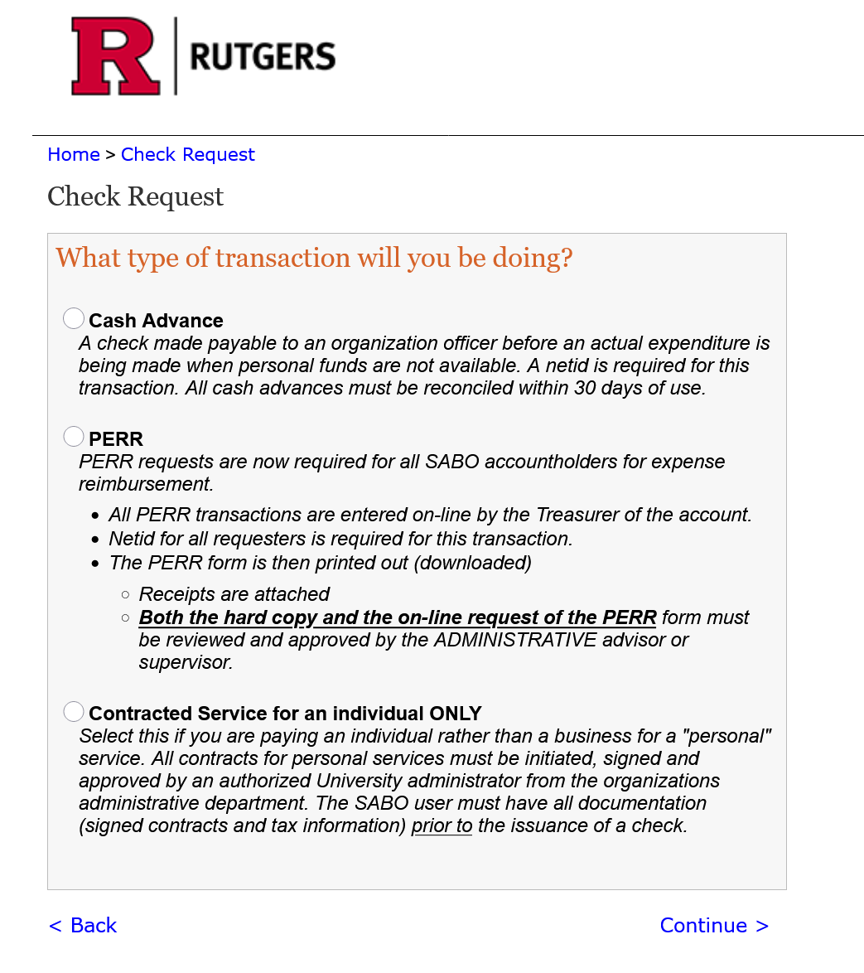

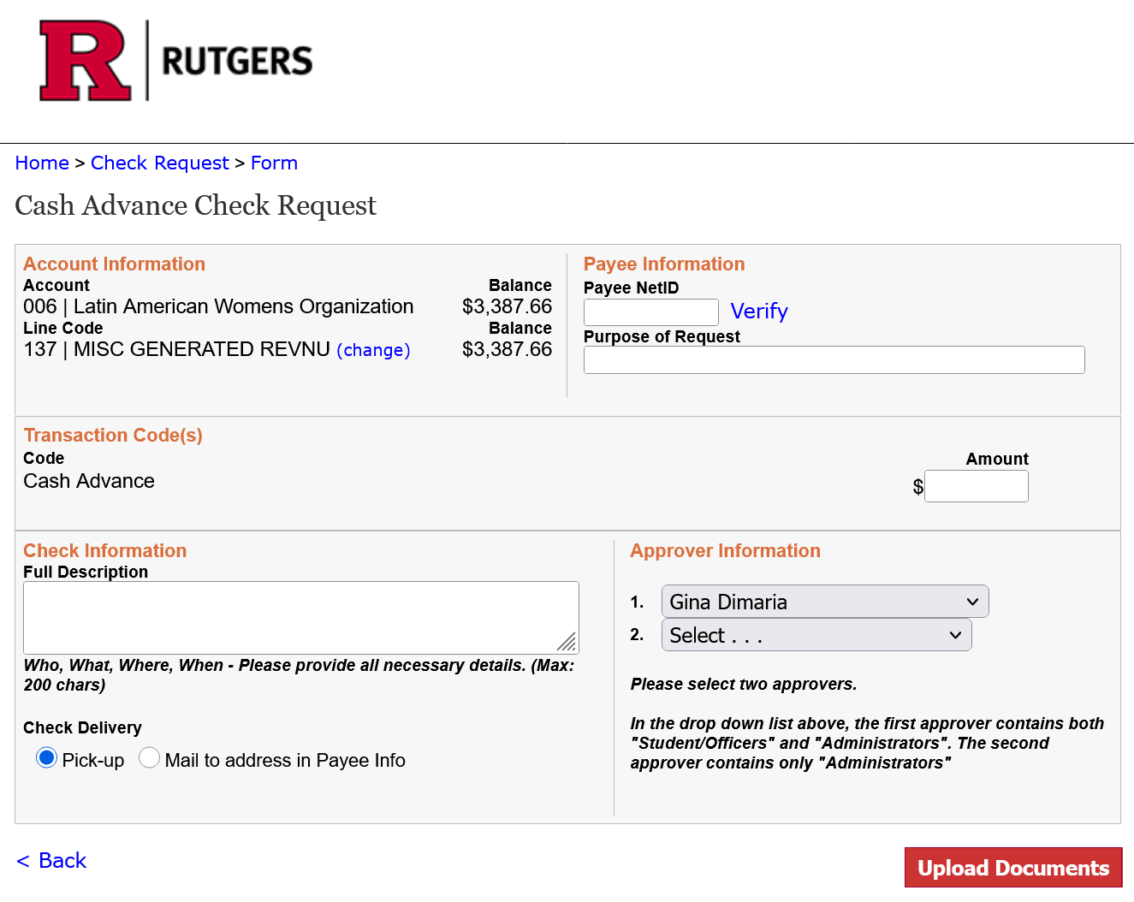
Use “Contracted Services” for persons performing a service after the contract has been signed by your advisor. (e.g. DJ, lecturer, etc.)

Use the “Cash Advance” to get access to funds before an expense at least two (2) weeks in advance.

Use the “PERR” to reimburse someone who paid for approved expenses with personal funds.

      - Cash Advance - A Cash Advance is an online Check Request that is issued to anyone with a Rutgers Net ID (required). Cash Advances are available when funds are needed prior to an expenditure being made or when personal funds are not available. All Cash Advances must be approved by your Administrative Advisor or by your supervisor if you are a professional staff member.

What is a CASH ADVANCE Transaction? A Cash Advance Transaction is for funds advanced to a student/staff to pay for expenses as they incur so that the use of personal funds is not necessary. A Cash Advance for an individual is a request for a check made payable to an organization’s officer, Residence Life Coordinators (RLCs), etc. before an actual expenditure is made. SABO policy is that two+ separate Cash Advances may be issued to your organization’s officers for general program expenditures, made payable to the organization’s officers or residence life coordinators. Cash Advance request must include a budget and business justification. The minimum dollar amount for a cash advance request is $100.00.

There are two types of cash advances:

      - A Cash Advance for expenses related to your event. Most of the time, decorations, food (non-catered), and supplies are the most common uses of these funds.

      - A Travel Cash Advance is when your organization is going away on a conference, trip, or event. These cash advances usually require documentation which substantiates the request. For air, rental car or rail reservations and hotel reservations, we require booking confirmation. We always prefer to pay for a hotel via SABO check request wherever possible.

Follow these simple steps and you will successfully complete a SABO Cash Advance Transaction!
- First, you must request the advance at least two (2) weeks before funds are needed.
- Cash the check (by depositing check in your bank account).
- Spend the funds on appropriate items.
- Credit card statement is needed as proof of payment if documentation does not indicate a zero balance. The transaction on the credit card must indicate “posted” and not “pending.”
- Cash Advance checks must be picked up at the SABO window during normal business hours (our hours are 9am until 4:30pm). We require cash advances to be picked up from our office.
- Reconcile the advance within 30 days from when the check was issued (check date).
- Cash Advances must be reconciled in person at the SABO window, by the payee of the check.
- Please have all supporting documentation/receipts and reconciliation sheet filled out prior to coming to the SABO window.
- You can now upload the excel budget for your cash advance within the request See below:
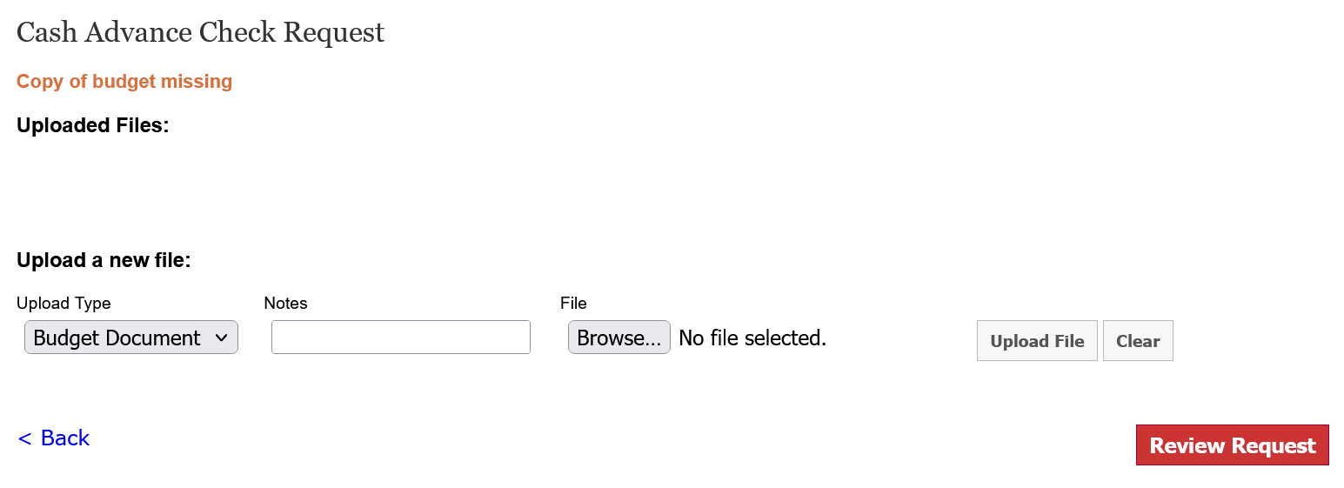

- Any unused funds must be deposited back into the account either by cash or check, note: no electronic payments are accepted at SABO.

Cash Advances may also be issued to professional staff for specific programs or events. A Cash Advance will not be issued to a staff member for non-program expenses or non-student related travel. At times, you may need to request a Cash Advance. Requests for Cash Advances must be for a specific purpose and must have accompanying documentation to support the request.

Please be sure to review the NEW Treasurer’s Key TIP Sheet for Cash Advance Transactions.

PERR REQUESTS

  - Program Expense Reimbursement Request (PERR) - The PERR form is used to reimburse individuals of your organization for out-of-pocket expenses. To be eligible for a PERR reimbursement you must have an RU Net ID. All PERR forms are submitted online by the Treasurer.

  - SABO strongly encourages PERR from submitters to be familiar with the requirements for getting reimbursed. PERR form requests must state the purpose of the request, and the program and dates to which the expenses are associated. Additional documentation that may be requested is at the discretion of the SABO Office.

  - To Enter a PERR Check Request (before planning to reimburse expenses, make sure expenses are consistent with departmental guidelines on spending and purchasing):

1. Click “Check Request” from the SABO Online Dashboard, enter and “Select” the Account Number, and “Select” the Line Code you wish to use.

2. Choose “Person” on the pay-to screen and choose “PERR” from the list of transaction types.

3. Enter the payee Net ID and verify the name and an address has auto populated
Special Note: You can “Add” as many Transaction Codes as you need. A PERR is for ONE PAYEE, from ONE LINE CODE; however, it can pay multiple receipts or multiple events. See the next page for an example.
NOTE: an address must be filled in even if the check is marked for pick up.

4. Enter the “purpose” of the reimbursement. (Ex: Decorations purchased for end of year event.)

4a. You can enter multiple lines under transaction codes for each receipt for the PERR if there is more than one receipt and payable to the same person.

5. Choose the transaction code from the drop-down tab, description again of reimbursement, and the dollar amount of the reimbursement. Then select the “Add” button in blue.

6. There are three drop-down tabs that will require an answer to proceed with the request.

A. Check Receipt Lost Status asks: HAVE RECEIPT OR LOST RECEIPT If receipt is lost then a lost receipt form needs to be completed and uploaded into this request.

B. Another Person’s Credit Card Used: YES or NO. If a parent (or someone other than the payee) credit card was used to make the purchase, a Consent to Reimburse form must be completed and uploaded into this request.

C. Includes a Group Meal Expense: YES or NO. This will require an itemized receipt showing all food from the business eaten at as well as a list of names of all who ate the meal uploaded in the request when you add the documents.

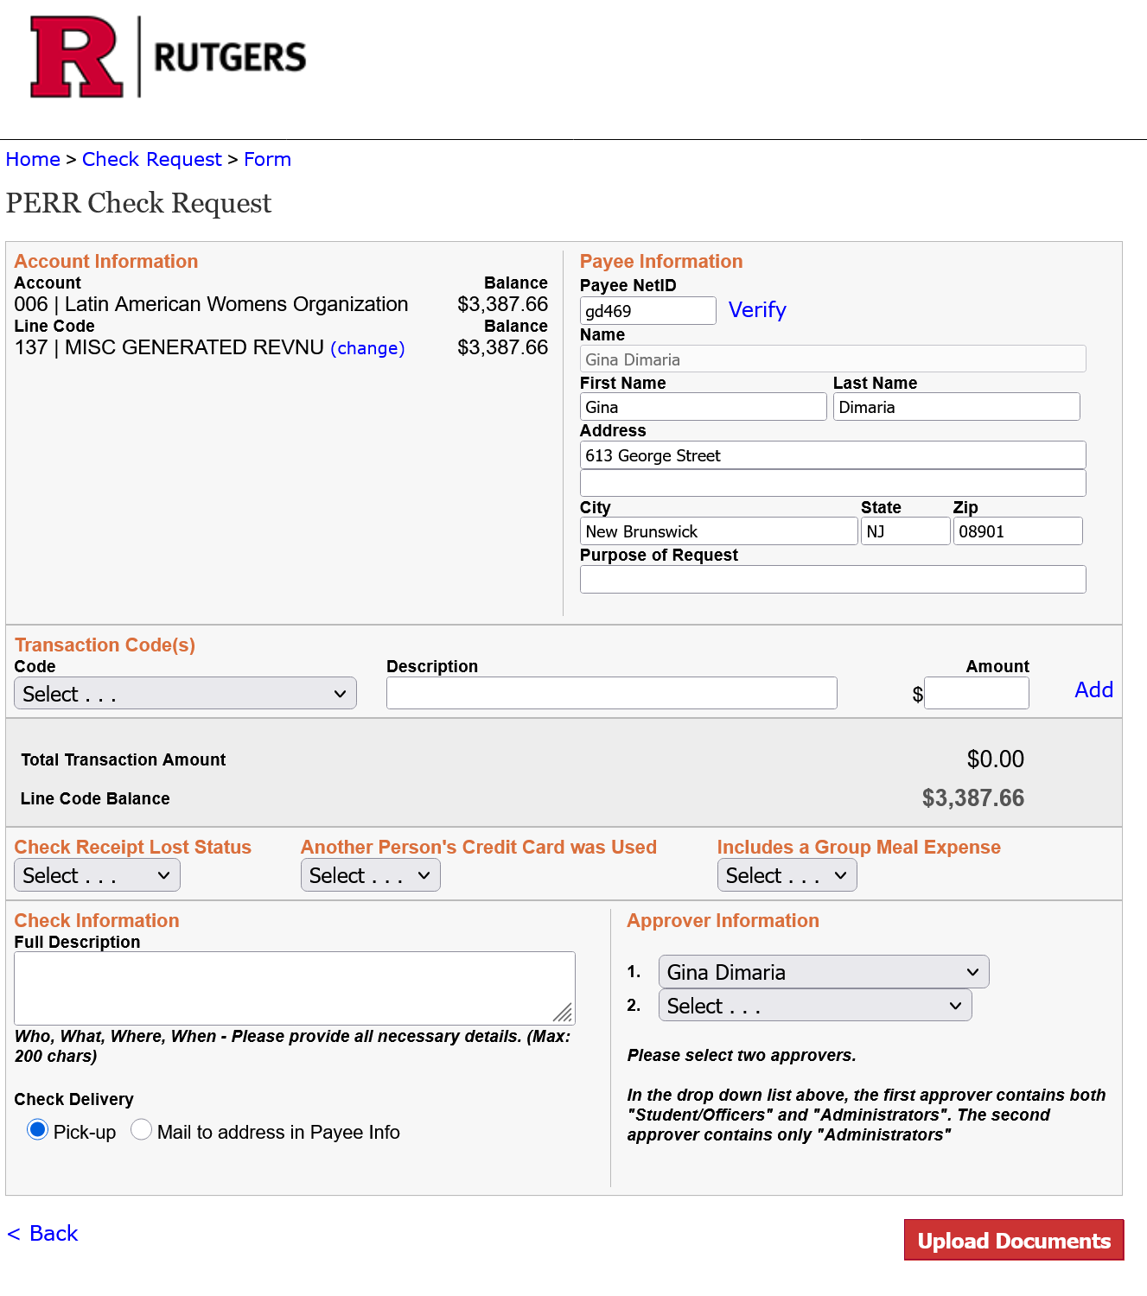

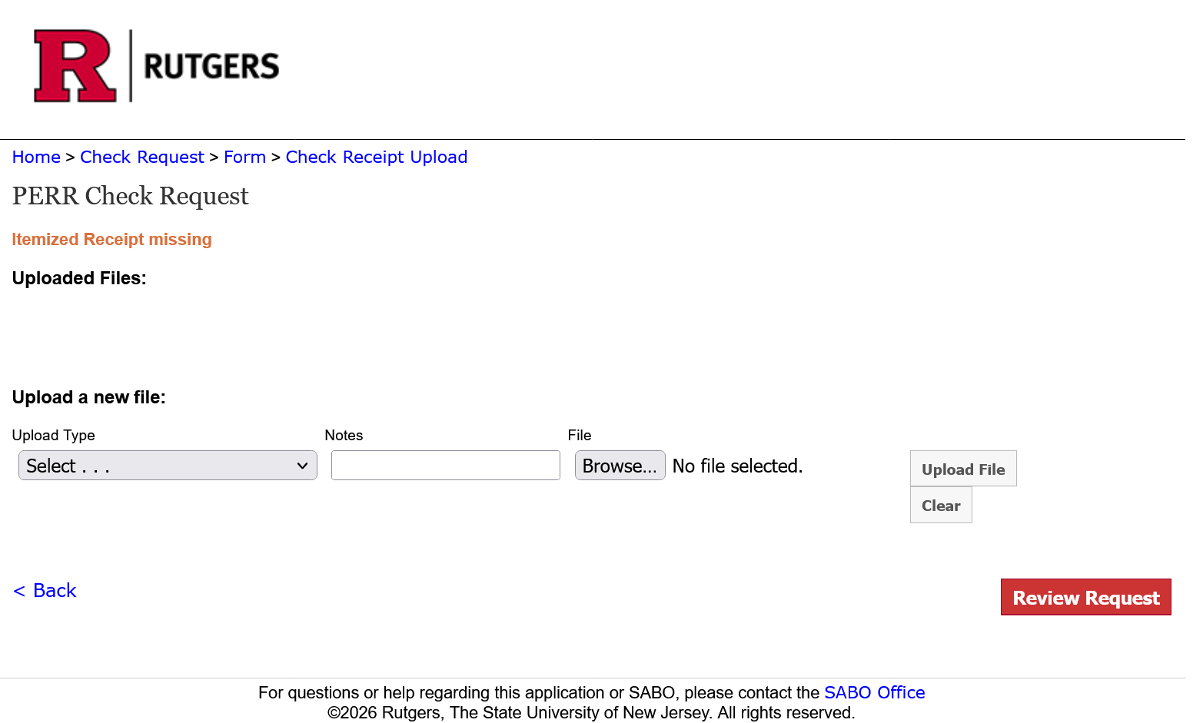

On the next page, you will need to upload any receipts for the purchase(s) made.
You must answer the first drop down box.
Click on the “browse” button and find whatever receipts needed for this PERR and select them from your files and then click “upload file(s)

Please note that SABO cannot open images/receipts/documents when they are in HEIC format, preferably PDF format, we also can accept JPEG, and JPG files as well.

After uploading the necessary documentation, click on “Review Request.”
This will take you back to the previous page.
If everything looks correct, then hit “Submit Request.”

After the treasurer enters the PERR request, it is routed to the administrative advisor for review and approval before SABO final reviews.

Notes can now be added to the request between the Advisor, treasurer, and SABO staff.

Any of these notes will be sent to your Rutgers email, may be for any additional documentation needed before the request can be approved.

Example below:
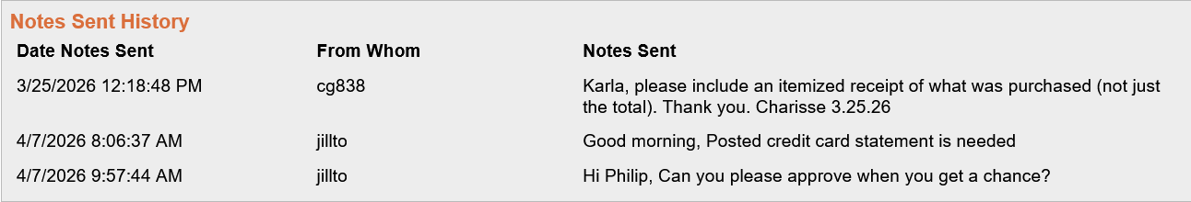
Check to make sure that all information is correct and is included. If you are mailing the check to the pay, double check to make sure that the delivery address is correct. IF YOU NEED TO MAKE CHANGES, use the “Back” button in the lower left. Do not use the browser back button.

PERR forms may be submitted up to 30 days after the expenditure was incurred. Failure to submit the PERR form within 60 days may result in nonpayment of the request and/or a delay of reimbursement.

PERR requests for “gift cards,” awards, or prizes, over $100.00 must also include the submission of a fully completed (including social security number – SSN- of Payee) Rutgers University Student Activities Business Office Prize, Award, and Gift Card Information Form.

Supporting documentation for purchases made on Amazon.com should be “Final Details for Order#.” This document shows that items ordered were shipped and confirm payment information (method, billing name, and address.). See sample under Treasurer Information in sabo.rutgers.edu.

        - Multiple Receipts, One Payee – If one student or staff member is being reimbursed from a single Line Code but you have multiple receipts (program supplies purchased from multiple vendors, for instance), the SABO advises Account Holders to condense the reimbursement on one PERR form. When entering the information online, simply “ADD” descriptions of the relevant expenses within a single Line Code until all receipts have been accounted for. This allows SABO to process one check for the payee and will speed up your time entering the Check Request.

THINGS TO KEEP IN MIND WHEN SUBMITTING A PERR FORM
- PENDING credit card charges are not accepted.
- Any charge of $500 or more the POSTED credit card statement showing name and charge is required.
- Paying with gift cards or using any credits/rewards are NON-REFUNDABLE.
- Buying personal items on the same receipt for SABO reimbursements will not be accepted.
- Gas reimbursements must be the day before, day off, or day after your approved trip.
- If you do not receive prior approval for your trip but decide to do the trip anyway no reimbursements will be allowed
- For any rideshares (Uber/Lyft) you can only tip 20% and no upgrades are allowed (must show business justification)
- SABO does not reimburse for any additional add-on charges, for example: preferred airline seat, travel insurance, hotel insurance, airline insurance, and hotel cleaning fees (This is not a complete list)
- Meals for approved travel trip is $20 per day per person for in-state and $30 per day per person for out-of-state travel, this is inclusive of tips and taxes as well.
- Before giving out prizes make sure you read the prize policy
- The consent form is only needed if PERR payee is different than the person who paid, for example: a parent/sibling/non-Rutgers friend.
- Never pay a contracted vendor, you can only pay by contract.
- Proof of payment is required for online purchases, (must show that a credit card was charged)

At any time, SABO may require more information or documentation.

Many PERR requests submitted are for purchases made from Amazon. Here are a few helpful tips on Amazon reimbursements and what is needed:
  - Full invoice is required that shows all items that were purchased and the full billing information.
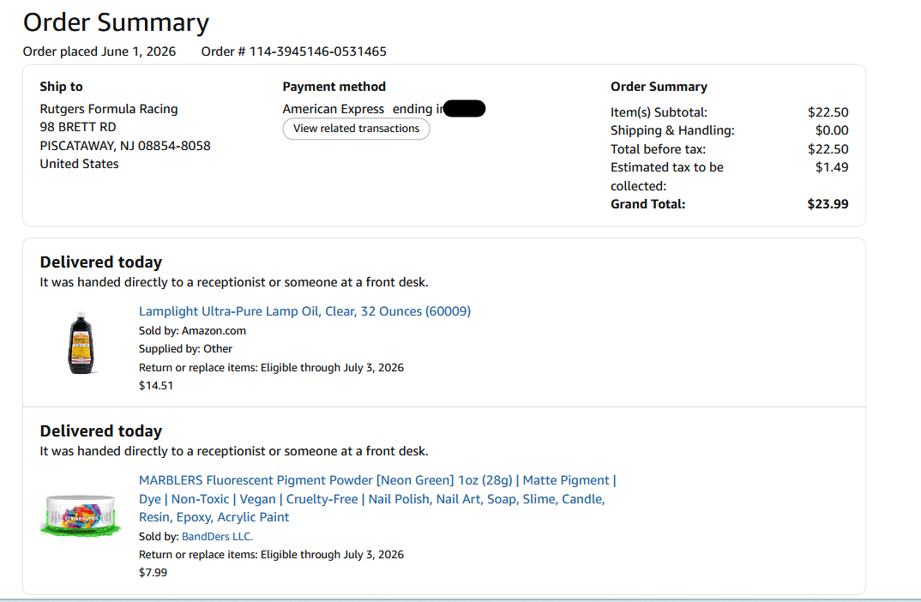
Example of an Amazon invoice: what we would need

If any items are returned, the full and complete invoice that shows the purchase and the returns are needed to be reimbursed.

If the billing address matches the PERR payee address, but with a different person’s name listed (for example parent’s name is listed) NO consent form is needed.

If the billing address does not match the payee address, a consent to reimburse form is then needed and/or posted credit card statement showing payees’ name.

For any invoices paid by credit card:

If the amount shows a $0 balance and no credit card info was given, then you will also need to upload the posted statement showing the charge.

If the amount shows that it was paid and no payment info is listed, then the posted statement also needs to be uploaded.

PAYING INDIVIDUAL CONTRACTS AND VENDORS

      - Individual Contracts – For information about paying individuals by contract, see Contracts. To pay a previously negotiated and approved contract, submit an online Check Request with accompanying documentation (original signed Contract and W-9 form) to the SABO and obtain Administrative Approval. This process follows the same outline as the Cash Advance and PERR procedures.

    - Payments to Vendors – Vendors are businesses located at Rutgers as well as those outside. A common example of a vendor would be any of the food businesses in Rutgers Student Centers. Most of these vendors will provide services and bill groups with an Invoice. When entering a Check Request to pay a student center vendor, click on the “Pay by Invoice” to bring up a list of Commonly Used Vendors.

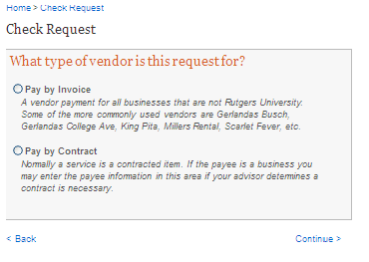
Performers, DJ’s Guest Speakers
Vendor other than Rutgers University. Examples are Gerlanda’s, Qdoba Busch Campus, Szechwan Ichiban
      - Pay by Invoice – If you receive an invoice from a non-Rutgers University vendor (meaning that the vendor is not a unit or department of the University) you can generate a Check Request by selecting “Check Request,” then “Vendor,” and “Pay by Invoice.” Selecting “Pay by Invoice” in the SABO Online system will bring up a list of commonly used vendors, most of whom are food providers located in Rutgers Student Centers. When you receive an invoice from a vendor not on the list of commonly used vendors, you may submit a Check Request to the SABO for payment to the vendor by entering the vendor manually.

      - Be sure to fully explain the reason/purpose for the purchase and all relevant information on the Check Request and include the invoice number. It is important to input the invoice number with your Check Request. This invoice number is normally printed on the check and is used by both the SABO and the outside vendor to record payment. The invoice or bill from the vendor must be submitted to SABO with a Check Request Number as documentation for the Check Request. Checks will be mailed to the vendor if the vendor address is entered on the Check Request. If there is no mailing address associated with the online voucher, the check will be held at the SABO for pick-up by an Account Officer.

      - SABO does not pay on Quotes or Estimates. When submitting a check request -> invoice, please ensure your supporting documentation is an invoice.

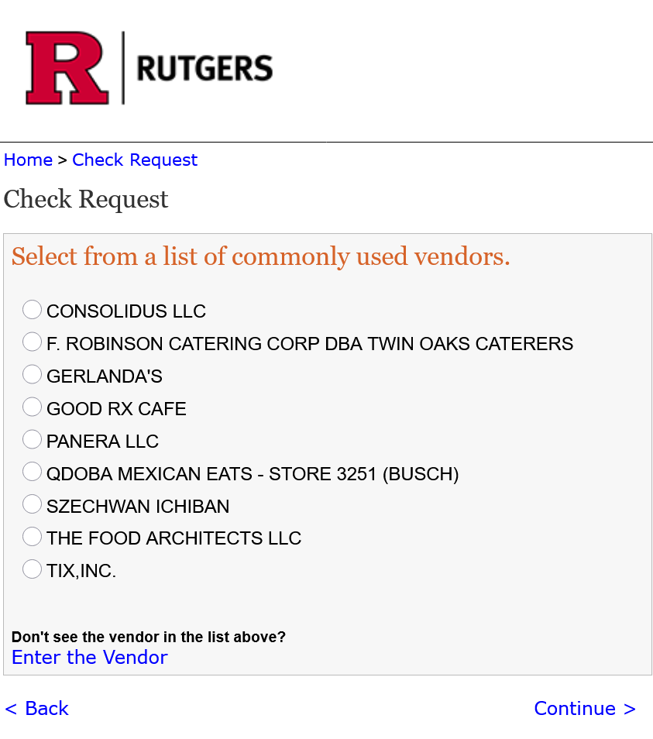
Here is a list of commonly used vendors:
Most Rutgers departments that would issue an invoice for services are listed here. If you have been invoiced and you do not see the unit listed here, contact the SABO at sabo@echo.rutgers.edu and we will add the unit or department.

      - Paying Vendors by Contract – For information about paying vendors by contract, see Contracts, pg. 27. To pay a previously negotiated and approved contract, submit an online Check Request with accompanying documentation (original signed Contract) to the SABO and obtain Administrative Approval.

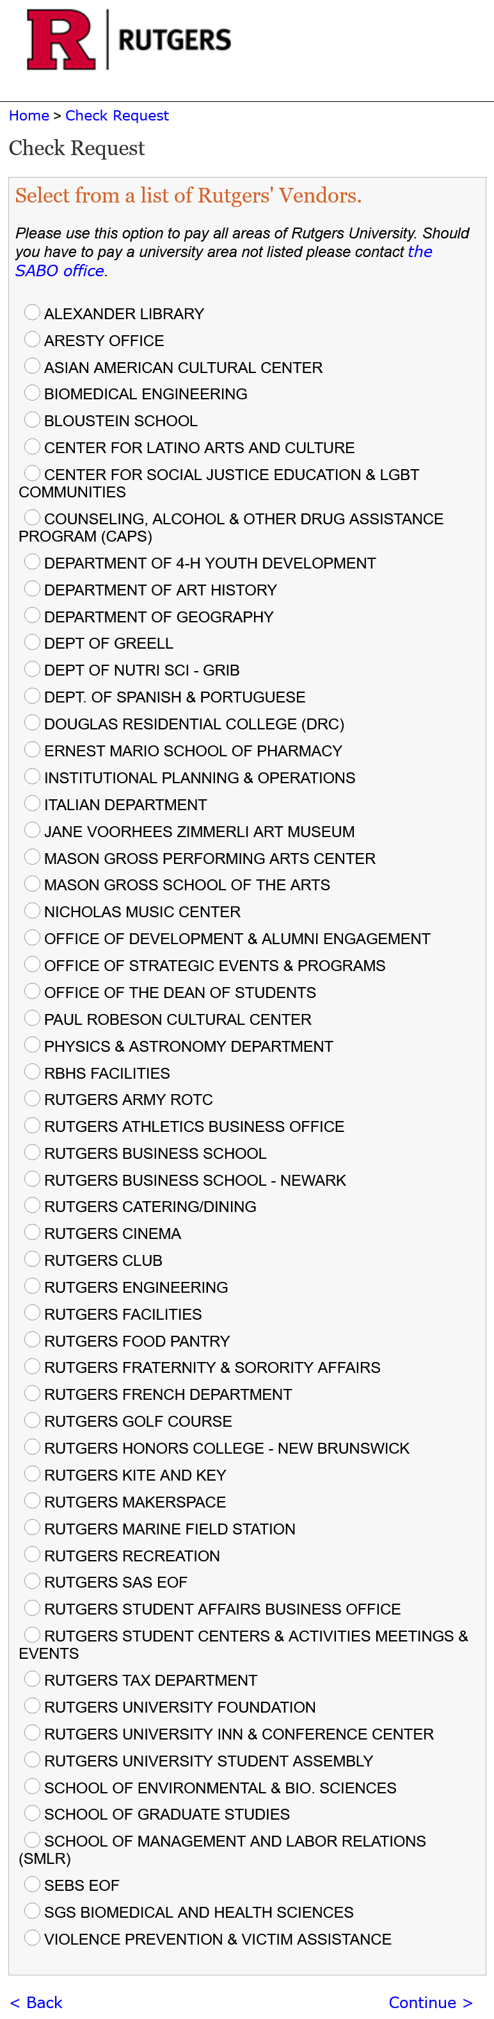
      - Payments to Rutgers University - Many of our Account Holders make checks payable to different Rutgers University areas or departments. We are pleased to announce a new payment type available for commonly used Rutgers areas/departments. This Check Request option is called “Rutgers’ Vendors.”

Most Rutgers departments that would issue an invoice for services are listed here. If you have been invoiced and you do not see the unit listed here, contact the SABO at sabo@echo.rutgers.edu and we will add the unit or department.

Each Rutgers area has its own type of identifier (number) issued with its invoices or contracts. For example, Rutgers Dining will have a contract number. Student Centers Reservations will have an invoice number. These identifiers must be entered for all Rutgers’ Vendor payments. If you need to make a payment to a Rutgers area not specifically listed on the Rutgers’ Vendor list, please contact the SABO office and we will add the area for you!

- Donation (Charitable) Advance - A check may be requested made payable to a recognized charitable organization that has the status of a non-profit organization based in the United States 501(c). At times, the SABO may require documentation to verify the legality and the tax status of the charity. When accessing the SABO Online system, choose the Donation Advance category. A letter will be attached to the check by SABO requesting that the charitable organization provide a receipt for the donation. (The Check Request steps for a Donation Advance are the same as those for a Cash Advance.)

      - Donation Reconciliation -To reconcile a charitable organization Donation Advance, an acknowledgement letter or receipt from the charitable organization is required.

      - Stop Payments, Voided Checks – If a check issued by the SABO is lost or stolen, an Account Holder may place a Stop Payment on the check after 30 days of its issue. The SABO staff will attempt to confirm with the bank that the check has not yet been cashed or deposited. Please note that payment of a check already cashed or deposited by the payee cannot be stopped. The Account Holder must complete a Stop Payment Request Form (see page) and return it to SABO. After the Stop Payment Form is processed, a new check can be issued. Keep in mind that this may take a few business days to process and reissue. Below is the Acknowledgement & Fee Notice when placing a Stop Payment.
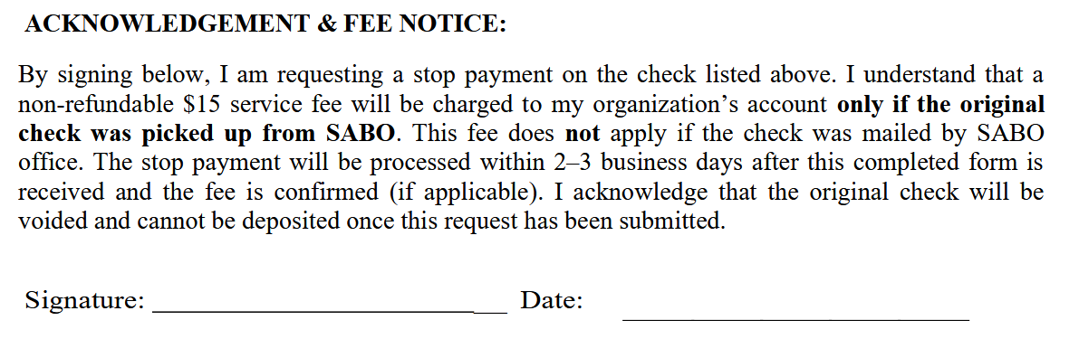

    - If a processed check is no longer needed or is known to have been destroyed, it can be Voided rather than stopped. If you are in possession of the check, simply write, in BLUE ink, VOID across the face of the check, and return it to the SABO. The check will be voided and the amount credited back to the account. Only void a check in your possession or known to have been destroyed. The SABO will void a check at no charge.

    - Documentation – By far, the most common documentation required for transactions at the SABO are Contracts, Receipts, and Invoices. For some Check Requests these are the only types of documentation that will be required – for expenditures enumerated in our Specific Spending Policies (See pg. 35) additional documentation is often necessary. SABO reserves the right to request additional documentation before any check is printed.

All documentation should be labeled with the check request number of the transaction with which it is associated. This includes all Receipts, all Contracts, all Invoices, etc. The check request number should be copied from the “Successfully Submitted” screen at the end of SABO Online requests.

All documentation deemed necessary to support the Check Request must be uploaded to SABO Online before a check can be printed.

Contracts - Contracts are legal agreements developed to protect your organization’s interests as well as the supplier’s interests. The contract or agreement will specify all information pertaining to the goods and/or services about to be received, so that there is no question of the expectations of both parties. Administrative Advisors are authorized to negotiate and sign Contracts. Always work in cooperation with your Administrative Advisor when a Contract is needed. Be careful not to enter any written or verbal Contracts with Vendors or individuals.

Examples of services that normally require a contract (not all inclusive). Please check vendor approved list.

- Non-Rutgers Catering
- Off Campus Retreats and Banquets
- Bus Rental – check approved list
- Performances/Lecturers/Coach/Trainer
- Non-Rutgers Equipment Rental

        - Contracting with Individuals - Whenever an Account Holder is paying an individual for “personal services,” an executed Contract or letter of agreement along with a W-9 form must be provided to the SABO office with the check request number for the check printing to commence. Please be sure the address on the contract and the W-9 are the same.

All Contracts and/or letters of agreement (service agreements) and W-9 form must contain the full name, home address, telephone number, and social security number or federal tax ID number of the individual or Vendor receiving payment. This information is required by the University and by the United States Internal Revenue Service. No exceptions can be made.

All Contracts for personal services, outside food vendors, off campus facilities, etc. provided to a student organization must be signed and approved by an authorized University administrator. A student Account Holder may not sign a Contract. Each Administrative Advising department has a List of Approved Signatories authorized to sign Contracts. Please be sure to check with your area on who is eligible to execute a Contract. Fully signed and executed Contracts must be received by the SABO before payment can be made.

        - Documentation for Contracts - Checks will not be released without an original signed Contract on file at the SABO. Completed Contracts must accompany check requests to the SABO for a check to be processed. Once a check is issued, it can be picked up on the day of the event or mailed to the Payee after the day of the event.

        - Free Services - Even if a service or performance is free of charge, it is strongly recommended that any group planning an activity contact their Administrative Advising department to determine whether Contracts are needed. This should be done well before any verbal or written commitments are made.

        - Paying University Faculty, Staff, or Student Staff for Services – University Faculty, Staff, and Student Staff are not to be compensated for services with a SABO check. The payment must be processed through the University Payroll System. (See Compensating University Employees, pg. 42).

      - Receipts - All receipts submitted for reimbursement should be marked paid or have a zero balance. Submitted reimbursements for an individual item over $500 require original receipts with the name and address of the vendor on the original receipt - you must show proof of payment with a credit card or bank statement verifying the purchase. SABO will not accept and will not reimburse any individual expenditure greater than $500 with the only documentation being an invoice or receipt marked PAID or PAID IN CASH. Credit card statement must show the transaction posted and not in pending status. Additionally, please note these policies about receipts submitted to SABO:

        - Original Receipts – Original receipts are required in all cases. Copies of receipts will only be accepted with a written explanation as to why the originals are not being submitted and only for certain transactions. If a receipt is lost, a Lost Receipt Certification Form must be completed.

        - Itemized Receipts - Receipts must be itemized to show what goods have been purchased. All submitted receipts should state the name and address of the vendor from where the purchase was made. (We realize that some small businesses may not have the name and address of their establishment printed on the receipt. If this is the case, it may be written on the original receipt by the requestor.)

          - If a purchase is made online, an itemized invoice or email confirmation with details of the purchase or other documentation must be submitted along with proof of payment. A copy of the credit card statement or the PayPal confirmation is the preferred documentation.

          - If a receipt is for food served at a restaurant, the names of the attendees, along with an itemized bill of what was served is required. A credit card statement without an itemized bill is not acceptable.

        - Personal Items on Submitted Receipts - Personal items should not be included on submitted receipts. SABO reserves the right to reject any receipt not in compliance with approved program or event reimbursements. Receipts submitted to SABO should only contain program or event expenses.

        - One Receipt, One Reimbursement – The SABO office will process a maximum of one reimbursement check per receipt. Do not attempt to “split” a receipt into more than one reimbursement. (If multiple purchases are made for one event, by multiple people, it is recommended that each person check out from the store, restaurant, or place of business separately.)

      - Invoices – Invoices are bills for services used often by businesses to track their accounts receivable. If submitting a Check Request to pay an invoice, please include the original invoice, note:(SABO does not pay off “estimates” or “quotes”) as part of your documentation. Please deduct any sales tax or gratuity fees charged if it appears on the invoice as Rutgers University is Tax Exempt (pg. 12). If your expense is listed under the SABO Specific Spending Policies (pg. 37), please also include any additional required documentation.

      - Documentation for Online Purchases – If a purchase is made online, an itemized invoice or email confirmation with details of the purchase or other documentation must be submitted along with proof of payment. A copy of the credit card statement or the PayPal confirmation is the preferred documentation.

      - Additional Documentation for Specific Spending Policies (See Specific Spending Policies, pg. 37) – SABO reserves the right to require additional documentation (documentation beyond a receipt) for any Check Request that is processed. To make sure that you have the necessary documentation, please reference the Specific Spending Policies starting on page 37.
  - Transfers

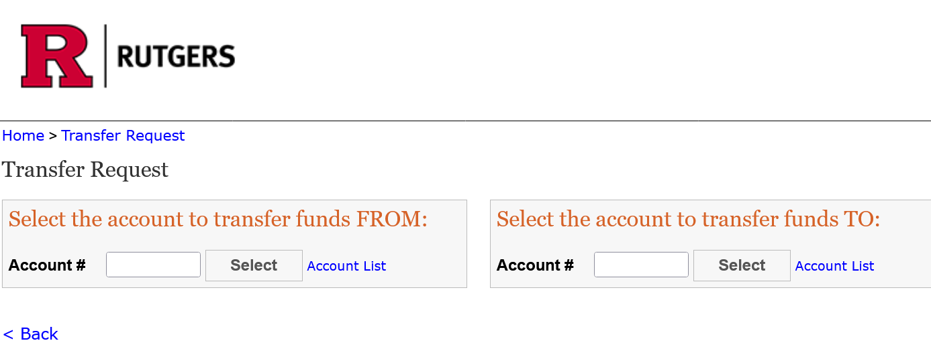
Online Transfers between SABO Accounts (Inter-Account) - Transfers of this nature are often associated with the Co-sponsorship of programs. Transfers between SABO accounts must be initiated by the “from” account and will require approval from an Administrative Advisor. If the co-sponsoring accounts are funded by various sources, it is best to discuss the plans for the event in detail with an advisor before any commitments are made.
Enter your account number then click “select”
1.Enter the account to transfer from. (This must be an account you control.) Then click select.
2. After selecting the account to transfer from, click the “Select” button and the Line Codes in the account will appear.

1. Enter the account to transfer from. (This must be an account you control.)

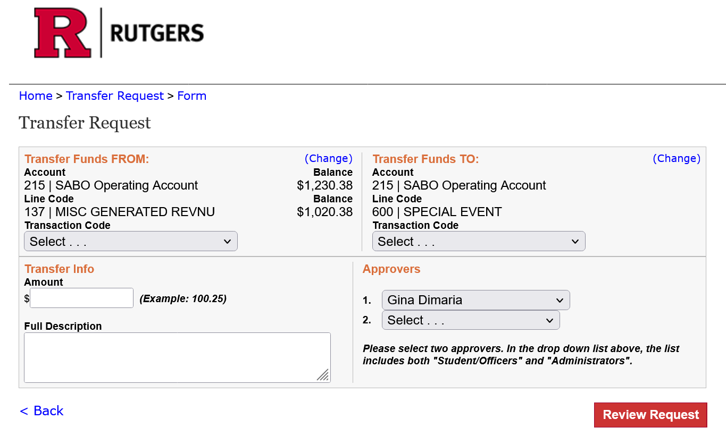
4. After selecting the Line Code, enter the account to transfer to.
A similar box of Line Codes will appear, then select the Line Code to transfer to.
from.

The example used shows an Intra-account tansfer, or transfer between lines. There is very little difference between Inter-account and Intra-account transfers in the SABO Online system. Please consult with your Advisor BEFORE transferring funds to another group or transferring funds to allocated or funded Lines.

      - Co-sponsoring Events – SABO does not approve or reject Account Holder’s plans to Co-sponsor an event – program planning takes place under the advisement of your Administrative Advising department. To protect the interests of your group, it may be necessary to formalize an agreement through a Contract or other statement of mutual understanding. Again, please consult with your Administrative Advisor about program planning and funding.

    - Online Transfers between Line Codes (Intra-Account) - Most transfers within accounts will occur from Line 137, Generated Revenue, to another Line Code. Funds in allocated or budgeted Line Codes are often not permitted to be transferred out without prior authorization from your Administrative Advisor and your funding source. It is recommended that exact amounts are transferred to the destination Line Code (for example, transferring an extra $11.06 from Generated Revenue to your Administrative Advising department’s programming Line Code to cover the exact extra cost of an event or expense beyond what was budgeted or allocated). Transferring more than the exact amount needed will make it much more difficult for funds to be transferred back out of the Line Code. Consult a representative of your funding organization or department, in addition to your Administrative Advisor, if you believe that a transfer of allocated funds between Lines would be appropriate. (See Transfers, pg. 31).
Deposits – All funds collected by a group, organization, or association that maintains a SABO account, regardless of the source, must be deposited into the account (within one day of collecting the funds). A Deposit, like other SABO account transactions, must be completed by an Account Holder as indicated on the Signature Card on file.

    - Deposit Slip – To make a deposit to your account, you must complete a SABO Deposit Slip. All lines on the form must be completed including the “Comment” section. The “Comment” line is for a brief but relevant description of the source of funds, date of collection, intended use of funds, etc.

The Deposit Slip also lists the composition of the deposit. Space is provided to enumerate the checks, cash, and coins being deposited and their value. Similar items of the same value should be listed together (e.g., 5 checks @ $15). Once verified by a SABO representative, your Deposit will be credited to your account the next business day and you will receive a validated Deposit Receipt. This receipt should be kept and used to match the transaction and deposit reference numbers with those found in your Account Statement. All Deposits are subject to adjustment if the Deposit Slip is incorrect.
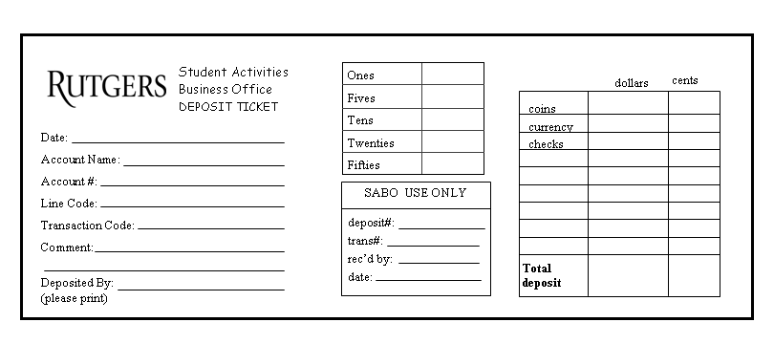
    - Depositing Checks and Money Orders - All checks and money orders Deposited at the SABO should be made payable to “Rutgers, The State University” – not directly to an Account Holder. The name of the organization or group associated with the account can be added on the memo or comment line on the bottom, left corner of the check. The Account Number and Line Code to be credited and the Transaction Code must also be listed in the memo area. (e.g., 999/137/061). Do not, in any way, mark, sign, adjust, or alter a check outside of this memo or comment area unless you are the maker (writer) of the check. Checks unable to be deposited will be returned to an Account Holder and the account will be adjusted. Additionally, please note that:

- Payment for uncollected (“bounced”) checks is the responsibility of the account holders and any associated group or organization. Deposited checks returned by the bank for any reason will be charged back to the account, plus any service fee charged by the bank. Uncollected checks will be returned to an Account Holder who is then responsible for attempting to collect payment.
- Post-dated or stale-dated checks are not accepted for deposit by TD Bank and will not be accepted by SABO. A “stale-dated” check is one which is dated more than six months old. A “post-dated” check is one which is dated for a day in the future and thus is not currently payable.
- Depositing checks which originate outside of the United States is not recommended. Depositing these checks may cause them to be returned as uncollectable or incur a bank charge on your account for currency conversion.

Depositing Coins and Currency – The SABO cannot accept large quantities of loose coins for Deposit. All quantities of coins that would fill a coin wrapper must be wrapped with the Account Number and Line Code to be credited on the outside. Coin wrappers are available at the SABO and provided to Account Holders free of charge. Quantities of coin that will not fill a coin wrapper should be listed and broken down by value and number of each on the Deposit Slip. (e.g., 5 nickels $0.05, 6 dimes $0.10). Similarly, all cash should be broken down by value and number of bills on the Deposit Slip. All Deposits are subject to adjustment if the Deposit Slip is incorrect. Additionally, please note that:

- The SABO cannot accept foreign currency or coin for Deposit. Identified items will be returned to the Account Holder.
- Any bills identified during Deposit as counterfeit or suspected of being counterfeit by the SABO or by TD Bank will be seized and no account shall be credited. Seized bills are required by law to be turned over to the federal government for investigation.

    - Generated Revenue - All funds collected by a group, organization, or association that maintains a SABO account must be deposited into the SABO account, within one business day of the event. Payment of any expenses directly out of revenue collected is prohibited - all expenses and payments must be processed through SABO. For example, it is against university policy to pay out a portion of cash collected as admission to an event, speaker, program, or performance whether payment was part of the event Contract. Any revenue generated in this manner must be deposited at SABO before it can be used to meet expenses.

    - Deposits from Events at Student Centers - Funds collected during a program held in one of Rutgers Student Centers should be turned over to the staff at that student center for safekeeping immediately following the event. You should include a Deposit Slip with the Generated Revenue to provide SABO with sufficient information about the money that was collected. Please discuss this policy both with your Administrative Advisor and student center staff if you are unfamiliar. Credit for the Deposit will be posted to your SABO account within three business days.

    - Funding From Other Rutgers University Sources - If you are receiving funds from a university department that does not maintain an account at the SABO (such as the Dean of your School), the funds must be transferred via a Rutgers University check. Following these procedures will expedite the transfer of funds into your SABO account:

      - Explain to representatives of the funding source that all funds should be transferred into your SABO account by check made payable to your organization c/o the Rutgers University Student Activities Fund.

      - Explain that a “check request” must be processed through the RIAS system. Instructions to transfer funds to your organization’s account are available on the SABO website. Call the SABO or visit the SABO website http://sabo.rutgers.edu to obtain a copy.

      - Once received at the SABO, the check will be deposited into the account indicated on the check. A copy of the Deposit Receipt will be placed in your organization’s account file to be picked up by the treasurer.

      - If requested, unused funds allocated to student organizations will be returned to the appropriate funding source (School or office) at the end of the academic year.
- Donations Received from Outside Sources - Donation and co-sponsorship funds received by student groups or organizations from sources outside of the University may be restricted. SABO reserves the right to question the source of outside funds being deposited by an Account Holder.

The SABO can help to determine if the funds can be deposited into an Account Holder’s SABO account or if they should be sent to the Rutgers University Foundation (RUF) for processing. The RUF is allowed to accept donation and co-sponsorship funds for student groups and organizations.

In most cases, funds for co-sponsorship and/or donations must be processed through the Rutgers University Foundation (RUF). The RUF is allowed to accept donations and co-sponsorships for student groups and organizations. Upon receipt of the funds, the RUF will send the donor an acknowledgement letter.

Your Administrative Advisor and the SABO should be notified if funds have been sent to the RUF for your student group or organization. The SABO will assist you by tracking all funds processed through the RUF. If documentation is supplied in a timely manner to the SABO, funds may be credited to your SABO account until the RUF processes the donation or co-sponsorship and sends the funds to the SABO.

  - Restrictions on Deposit Transactions

    - Wire Transfers - The University does not permit either incoming or outgoing Wire Transfers from SABO accounts. There are few, if any, circumstances under which such a transfer would be necessary or proper. Account Holders with questions about Wire or Electronic Transfers should consult with their Administrative Advisor and SABO Business Manager.

    - Electronic Funds Transfers (EFT, Automated Clearing House (ACH), etc.) - All forms of Electronic Funds Transfers are prohibited from accounts at the SABO. This includes both automated or electronic deposits to and electronic payments from the accounts.

    - In summary:
        - No outgoing wires
        - No incoming wires
        - No ACH/EFT
        - No international payments

Specific Spending Policies –

  - Food - Unless otherwise specified, “food,” “food purchase,” etc. refers to the procurement of meals, snacks, groceries, beverages, catering, etc., broadly defined. This policy applies to all accounts except for those fulfilling an administrative function.

Source of Funding: This policy applies to all food purchases regardless of the source of funds (such as generated revenue, student activity fees, program fees, etc.). Funding sources may specify additional restrictions on the purchase of food for specific allocations of funds. Administrative Advising Departments may develop and enforce more restrictive policies concerning food.

The following are examples of acceptable use of funds to purchase food for a program or event:
- Food for performers, artists, lecturers, service providers, etc. as part of a contractual agreement.
- Meals during approved travel programs (limited to $30.00 per person, per day, for out of state travel, inclusive of tax and gratuity. See your individual area’s policies and guidelines for further information).
- Food provided hospitality for events.
- Refreshments at a general meeting of your group or organization that is open to the public (not executive committee meetings, etc.).
- Food served in conjunction with approved training and retreats.
- Food served as part of a traditional and customary celebration/commemoration (beginning and end of year banquets, etc.), or study breaks.
- Meals for student volunteers working an event/program when the combination of student’s work or academic schedule and an event/program create a hardship for the student.
- Food for approved Residence Hall events.
- Food for student organization meetings is carefully restricted but may be appropriate in some cases. Speak with your Administrative Advisor about this policy.
- Food purchased with Generated Revenue at an outside establishment for a business meeting or event is limited to $20.00 per person, per day for in state, inclusive of tax and gratuity. Name of all individuals, purpose of function, and an itemized receipt is required for all these transactions.

**Required Documentation**: Reimbursements for food expenditures (PERR) or an online Check Request to a Vendor requires original itemized receipts or invoice (including the name and address of the Vendor where the food was purchased) to be submitted to the SABO prior to a check being issued. Names of attendees at any group sit-down event are required. A list of all attendees is not required for large catered events. Ticket stubs and/or credit card receipts alone may not be accepted as documentation for the expenditure.

- Travel - The following guidelines should be followed by all student groups and organizations when planning travel with their Administrative Advising department. Whenever a student group or organization is planning travel or trip activities, a Travel Itinerary and Trip Waiver must be completed and submitted to the appropriate Administrative Advising department.

- Travel Suggestions
- DO always obtain your Administrative Advisor’s approval in writing before making any travel arrangements.
          - DO shop around for the best travel option and value.
          - DO use a university check (from SABO) to directly pay as many service providers as possible for travel-related expenses such as hotel, airfare, etc.
          - Avoid if possible, using your personal credit card or personal funds to make travel arrangements for anyone else.
          - DON’T use your personal credit card or personal funds to make travel arrangements unless they have been approved in writing by your Administrative Advisor.
- Travel Finances - To make the financial aspects of travel planning easier, make an appointment to see your Administrative Advisor to help you plan your trip. Remember, no commitments, verbal or otherwise can be made until Contracts are signed or funds are secured. Each type of travel requires specific arrangements. Students are encouraged to pay for travel arrangements using a university check whenever possible. Your Administrative Advising department can assist your organization with travel reservations for airlines, lodging, and vehicle rentals for club events and programs. Refer to the following sections for specific types of travel arrangements.

Organizations planning to participate in tournaments, to travel abroad, or to go on a performing tour should contact their Administrative Advising department well in advance and in the early stages. Tours and trips abroad often require a minimum of one year to plan to execute successfully. This is especially true when fund raising is involved. Organizations planning such travel should contact the appropriate Advisor and provide a detailed proposal regarding the purpose, destination, financial arrangements, and anticipated date(s) of the travel program. As with all student organization programs, advance planning will ensure a smooth and enjoyable program. However, please contact your Administrative Advising department for assistance when making short notice or “emergency” travel plans: we can help make the process easier for you if you give us the chance. Remember, Trip Itineraries, Participant Rosters and Trip Waivers must be completed before departure. Enjoy your trip!

- University Representatives - For certain student organization trips, the University may determine that a faculty or staff representative is required to attend the trip as the designated University representative. This determination will be made as you plan your trip with your faculty/staff advisor.

- Reimbursing Travel – These instructions are for reimbursing travel. For Traveling with a Cash Advance, see pg. 37.

Remember to discuss with your Advisor payment options for lodging, transportation, and food before booking.

- Airfare – Airfare will be reimbursed for coach class only.

- Bus or Train – Bus or train travel will be reimbursed for the reasonable actual cost. Attach the original train or bus ticket to the PERR form.

- Car Rentals – Car rentals may be used when the overall cost of the rental is less than the cost of other means of transportation (e.g., taxis, limousines, airfare). Car rentals are only permissible for drivers that have completed the Rutgers University Defensive Driving Course. Attach original receipts for car rentals and the rental contract to the PERR form.

- Personal Car Mileage – Personal car mileage for travel will be reimbursed at IRS Mileage reimbursement rate, or a gas receipt showing the amount of fuel purchased. For all travel, be sure to list the origin and destination, the purpose and date of the trip, the number of miles/or the actual cost of gas and oil, and toll expenses (with receipts) on the PERR form with corresponding receipts.

- Travel Costs - Travel costs for local taxis, limos, buses, subways, and trains used while traveling will be reimbursed at actual cost. Attach receipts and clearly note origin and destination, travel dates, and explain the purpose of each trip.

- Lodging - Lodging should be paid by a check payable directly to the vendor or by Cash Advance. If this is not SABO will reimburse lodging expenses with the submission of an original receipt for a standard room showing a zero balance. Credit card receipts alone are not sufficient. Charges other than the room charges must be explained and any unallowable charges (such as movies or upgraded rooms for personal guests) must be excluded from the reimbursement request.
Must always request the hotel folio upon check-out, which shows all charges and payments for each room booked.
NOTE: that a LOST RECEIPT FORM IS NOT ACCEPTABLE AS PROOF OF PAYMENT, EVEN WITH POSTED CHARGE, IN PLACE OF NOT ACQUIRING A CHECK OUT FOLIO FROM WHICHEVER HOTEL YOU STAY.

Airbnb/VRBO/Home-Sharing
- Rutgers’ duty of care obligations extends to ensuring the safety and security of all student residences, including student travel residences. Rutgers cannot uphold those obligations with Airbnb, VRBO, or other home-share providers. Therefore, student organizations are not permitted to book this type of accommodation, for any reason, for Rutgers-related travel.

Traveling with a Cash Advance - Whenever possible, checks for travel expenditures should be made payable directly to the specific hotel, airline, or other provider of the travel services. These payments are to be processed in the SABO Online system as payment to a vendor (invoice). Since the travel has not yet occurred, invoice will not be available. Email confirmations or other documentation provided by the travel service provider must be submitted to the SABO as supporting documentation. When entering the Check Request information in the SABO Online system, use the confirmation number or estimated price as the “invoice number.”

Travel expenses paid by a Cash Advance may include payments for local, out-of-state, and foreign travel. Every effort should be made to pay travel expenses by a check made payable to the vendor. At times, however, travel service providers (vendors) may not accept checks issued by the SABO. In these circumstances, you may request an individual Cash Advance to use to pay the vendor.

All travel processed through the SABO must comply with the procedures and guidelines documented in the Student Affairs Department Travel Guidelines. At times and depending upon the type of trip, SABO may require proof that the guidelines detailed in the Student Affairs Department Travel Guidelines have been met. Refer to the Student Affairs Department Travel Guidelines for additional information.

- Travel Reconciliation (Cash Advance) - To reconcile an individual Cash Advance used to pay travel expenditures, supporting documentation for airline, bus and train travel, hotel, auto expenses, travel-related meals, etc. is required to be submitted to the SABO based on the following guidelines:

- Airfare – Airfare will be reimbursed for coach class only. The booking confirmation/itinerary from Direct Travel will be accepted as documentation to the Cash Advance Reconciliation form for air travel with proof of payment if cost is more than $500.

- Bus or Train – Bus and train travel will be reconciled for the reasonable actual cost. Attach the original train or bus ticket to the Cash Advance Reconciliation form.

- Car Rentals – Car rentals may be used when the overall cost of the rental is less than the cost of other means of transportation (e.g., taxis, limousines, airfare). Car rentals are only permissible for drivers who have completed the Rutgers University Defensive Driving Course. Attach original receipts for car rentals and the rental contract to the Cash Advance Reconciliation form along with proof of payment.

- Personal Car Mileage – Personal car mileage for travel will be reimbursed at the IRS Mileage Reimbursement rate. To save funds for an organization the advisor may elect to request the drivers to submit gas receipts in lieu of the mile allotment. Submission of Google Maps trip estimates or similar documentation is acceptable. Note the origin and return of the trip must be from/to Rutgers University and from the destination. The purpose of the trip, the number of miles/or the actual cost of gas and oil, and toll expenses on the Cash Advance Reconciliation form with corresponding receipts must be submitted.

- Travel Costs – Travel costs for local taxis, buses, subways, and trains used while traveling must be substantiated with receipts. Attach receipts and clearly note origin and destination, travel dates, and the purpose of each trip.

- Lodging – Lodging expenses require the submission of an original receipt for a standard room showing a zero balance along with proof of payment. Credit card receipts or a room portfolio alone are not sufficient documentation. Charges other than the room charges must be explained and any unallowable charges (such as movies or upgraded rooms for personal guests) must be excluded from the Cash Advance Reconciliation form.
- Travel Outside of the US - SABO reserves the right to request all documentation pertaining to travel outside of the US. In addition to Cash Advance travel documentation, the SABO reserves the right to request additional documentation such as executed Contracts, airline carrier information, and/or travel itineraries, etc. Failure to provide this information in a timely manner may result in SABO not reimbursing the parties for the expenses and contacting the Administrative Advisor.

- Printing, Publications, and Advertisements - University funds may be used to advertise events or programs but must be directed at the campus community. Student organizations are not permitted to advertise events in publications circulated off-campus.

**Required Documentation**: An example of any copies, forms, flyers, advertisements, or publications may be submitted as supporting documentation with an invoice, PERR, or Cash Advance Reconciliation form.

Trademark Licensing Program for Imprinted Supplies RUTGERS SWAG

To protect Rutgers University’s image and reputation, the Rutgers University Trademark Licensing program regulates the use of the University’s name and identifying marks. Rutgers Primary Licensee for Branded Merchandise is CONSOLIDUS, LLC. https://www.swagbyconsolidus.com/. All student organizations must use this vendor.
- Rutgers University has introduced Consolidus as the one-stop shop for all promotional and swag/giveaway needs. This includes all student organizations and University departments. To make things easy, every design on the website is now pre-approved and ordering items for your organization is easier.

- All items can be viewed at swag.rutgers.edu. All students can log on and browse using their Net ID. Presidents and Treasurers of each organization have the authorization to place order. Please see your advisor for information on how to log in.

- All orders will be paid by invoice directly to Consolidus. Treasurers will need to submit a check request/vendor/pay by invoice in SABO. Select “Mail to address in Payee Info” under Check Delivery. Be sure to E-mail /submit the invoice (not the quote or order confirmation) with the voucher “C” number in the subject line to SABO@echo.rutgers.edu.

- All SABO Account Holders purchasing imprinted goods such as T-shirts, sweatshirts, caps, mugs, promotional items, etc., displaying Rutgers University trademarks must use Consolidus. Consult with your Administrative Advisor if you are ordering items imprinted with your organization name or any other Rutgers University trademarks to ensure compliance with trademark licensing guidelines. Purchases not in compliance with university regulations WILL NOT be paid.

- Giveaways - RUSA and Residence Life allocated programming funds are to be used for programming purposes – giveaways, alone do not constitute a program. Funds allocated to a Programming Line Code may not be used to purchase items that are given away unless both the program and the purchase of the items are approved in advance by an Administrative Advisor.

- Scholarships - All scholarship or stipend awards should be processed through the Office of Financial Aid and are not to be awarded directly to the recipient.

- Charitable Donations (See Donations, pg. 27-28) –. All charitable donations must be funded through the Generated Revenue Line (Line Code 137 Misc. G/R). An Account Holder wishing to raise funds for a specific charity must work with their Advisor prior to the fundraising- US BASED Charities only. Advisors will have the authority to authorize all reasonable fundraisers and donations, provided 501(c) information can be obtained. Account Holders may not commit funds to any organization verbally or written without prior approval from their Advisor and the SABO. The Account Holder and the Advisor may also be required to provide further documentation regarding the organization to SABO. Checks must be made payable to the charitable organization’s name and may require a tax ID number. Charitable donations to individuals are prohibited. All charitable donations will be processed as a Donation Advance.

**Required Documentation**: A letter may be mailed along with the check to the receiving charity. The charity will then have to send a confirming letter of receipt of the funds, on their letterhead, to reconcile the Donation Advance.

- Prizes, Awards, and Gifts - Occasionally, student groups and organizations may include prizes and awards as part of their banquets, events, or hall programs. Prizes, gift cards, and awards are given to recognize an accomplishment, achievement, or an activity that does not require the performance of a service to the University. Awards, prizes, gift cards, and recognition gifts are allowed in limited circumstances. ONLY the Account Holder’s Generated Revenue is used to fund this expense.

When considering the purchase of a gift, it is more appropriate to collect voluntary contributions of personal funds to purchase a gift. It is prohibited to use the SABO for the purchase of a gift for a holiday, birthday, retirement, wedding, baby shower, bereavement, etc.

All prizes, awards, and gift cards over $100.00 funded by the SABO are reported to the University Tax Department.

Refer to your specific advising area for guidelines, to the extent that the expense is deemed allowable, reasonable, and necessary to carry out the mission of the organization or event.

**Required Documentation**: A Rutgers University Student Activities Business Office Prize, Award, and Gift Card Information Form (form on page 49) must be completed in its entirety (including SSN) as documentation for all prizes, gift cards, awards, and recognition gifts valued at $100.00 or more. The required information includes the purpose of the award, eligibility criteria, selection criteria and amount or cash value. In addition, the recipient’s name, social security number, home address, phone number, and affiliation with Rutgers University (faculty, staff, student, etc.) are required. If the recipient is an employee (staff or student employee) of the University, documentation must clearly state employment status, position, and department. Check Requests for a prize or award must clearly state the description of the event, the purpose of the award/prize, and the Administrative Advisor’s signature. All awards (cash and non-cash) must be reported to the Internal Revenue Service by the University as taxable income.

Documentation for the purchase of a non-cash prize, award, or recognition gift must also include original receipts and Vendor information. It is recommended that the disbursement of cash prizes and awards to non-employees be given in the form of a check made payable to the individual award recipient. Checks will not be released by the SABO until complete supporting documentation is provided.

When filling out a Prize Form, please note that if the prize recipient is a Rutgers student, no W-9 is required, just the Prize form filled out in its entirety of a single prize valued at $100.00 or more.

When the prize recipient is a non-Rutgers student, then BOTH a Prize form AND a W9 is required and needs to be filled out in its entirety, also for any prizes valued at $100.00 or more.
Please be aware of these policies before giving out any prizes.

- Compensating University Employees - Faculty and staff work with student organizations as a part of their commitment to and employment with the University. It is not necessary to reward them with gifts or honoraria and in most circumstances, it is prohibited. Consult your Administrative Advisor to determine if a recognition or commemorative gift is appropriate.

Appendices

  - Glossary of Terms

- Account Holder – anyone with authorized access.

- Account Number - 3- or 4-digit number unique to each account (e.g., 001, 1058). The account number is an identifier to separate one organization or one event from another.

- Account Statement - Statements of the activity of each account are available on demand from the SABO Online system. Statements generated online will show approved and past transactions, not current requests.

- Administrative Advisor – Approver in SABO System Ledger.

- Deposit Receipt – After confirming that the deposited items match the Deposit Slip, the SABO representative will present the Account Holder with a Deposit Receipt for verification with Ledgers and Account Statements. If the deposit was submitted other than in person by an Account Holder, a Deposit Receipt will be printed and kept in the account’s folder at the SABO office until picked up.

- Invoice – A billing statement from a service provider or company.

- Ledger - The record of expenditures, reimbursements, and check requests maintained by the account holder. It is used to compare and reconcile the account holder’s records with account statements produced by the SABO.

- Line Code - Line codes function as sub-accounts or accounts within your account and are 3 digits long. Funding is allocated to student organizations according to their budget and is separated into line codes based on its uses, its source, etc.

- President – read-only access.

- Transaction Codes– Transaction Codes are short identifiers for the type of funds being spent or deposited, or for the nature of items for which a Check Request has been submitted. They help to ensure that a transaction is correctly processed, that funds are spent on appropriate and budgeted items, and that adequate audit records are available in the future.

- Treasurer – primary account manager.

- Check Request Number– Each SABO transaction is associated with a Check Request Number when it is processed. It is a convenient way for SABO staff and the Account Treasurer to reference and find details about transactions. If a transaction has multiple parts (Cash Advance, in particular) all aspects of the transaction will be associated with the same Check Request Number – thus, it is not only a convenient way to search for a transaction, but also a useful way to keep track of diverse parts of the same transaction.

  - Links

    - SABO Website (Home | Student Activities Business Office - Division of Student Affairs | Rutgers University-New Brunswick)

    - SABO Forms (Forms | Student Activities Business Office - Division of Student Affairs | Rutgers University-New Brunswick)

    - RUSA Allocations Board (Store 2 — Rutgers University Student Assembly)

    - RUSA Allocations Resources (Resources — Rutgers University Student Assembly)

    - Register a New Student Organization (Student Organization Registration | Student Centers and Activities - Division of Student Affairs | Rutgers University-New Brunswick)

    - Rutgers Trademark Licensing (Trademark Licensing Policy for Rutgers University)

    - Rutgers Swag by Consolidus (http://swag.rutgers.edu/)

  - Contacts

    - Charisse Gutierrez, Business Manager, Rutgers University SABO (charisse.gutierrez@rutgers.edu)

    - Geraldine Howard, Accounting Assistant I, Rutgers University SABO (gjhoward@echo.rutgers.edu)

    - Jill Silverman, Accounting Assistant II, Rutgers University SABO (jillto@echo.rutgers.edu)

    - Gina DiMaria, Head Accounting Clerk, Rutgers University SABO (gd469@echo.rutgers.edu)


Copy of a SABO Deposit Slip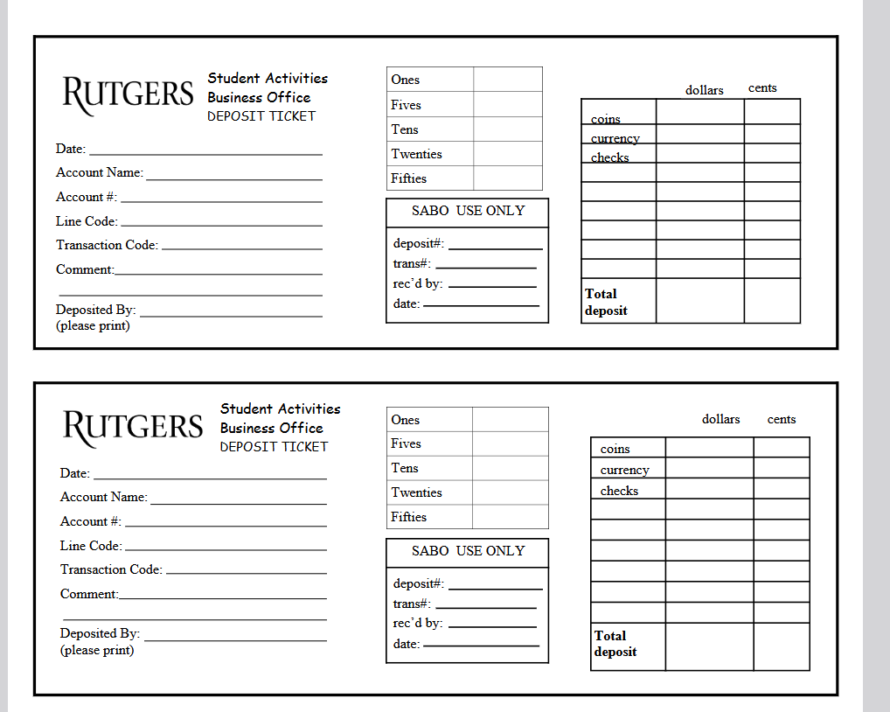

COPY of a SABO Consent to Reimburse Form
